Leaves “Energize” Our Streams!
Most ecosystems rely on the sun for energy. In many streams, however, sunlight cannot reach the water’s surface due to shade from the trees. Therefore, most streams rely on autumn leaf fall to supply much of the energy needed to support the stream throughout the year.
In the past, most of the small streams in the eastern United States were forested. Leaf fall from the forest was the main food resource for small streams.
The leaves that fall into streams collect in packs behind branches and rocks in the stream, forming natural leaf packs.
Leaves, falling in or near the stream, serve as food for many animals that live in the water. On the leaf surface, there are fungi and microbes that break down leaves and macroinvertebrates (insect larvae, crustaceans, etc.) which “process” leaves and support the flow of energy through the system.
Macroinvertebrates are often referred to as “canaries of the stream” because they function as living barometers that indicate changes in water quality.

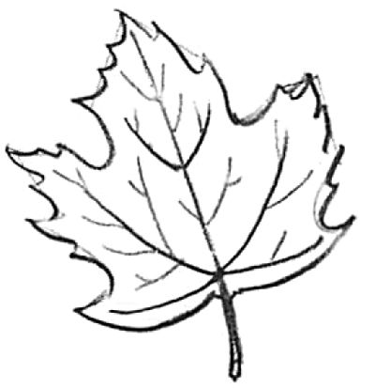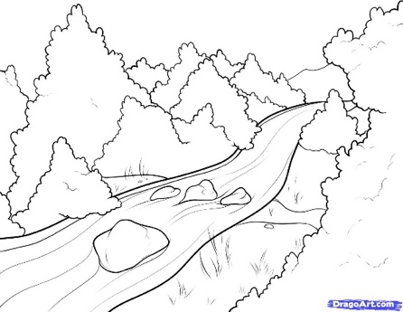

Text Dependent Questions (and additional questions (marked with an *) that require research)
- How do most ecosystems get energy? ___________________________________________________________
- How do many streams get their energy if the sunlight is blocked by the shade of the trees? _______________ __________________________________________________________________________________________
- What is a “natural leaf pack”? _________________________________________________________________
- What stream animals depend on leaves as for food? ______________________________________________
- What are microbes?* (Give a few examples.) _____________________________________________________
_________________________________________________________________________________________
- What are macroinvertebrates?* (Give a few examples.) ____________________________________________
__________________________________________________________________________________
- What did the author mean by “Macroinvertebrates are often referred to as “canaries of the stream”? _________________________________________________________________________________________
_________________________________________________________________________________________

KEY KEY Text Dependent Questions (and additional questions (mark with an *) that require research)

- How do most ecosystems get energy? From the sun
- How do many streams get their energy if the sunlight is blocked by the shade of the trees?
Leaves that land in the stream.
- What is a “natural leaf pack”?
a collection of leaves behind a barrier (branch or rock)
- What stream animals depend on leaves as for food?
Fungi and microbes and macroinvertebrates
- What are microbes?* (Give a few examples.)
A microbe, or “microscopic organism,” is a living thing that is too small to be seen with the naked eye.
(examples, Bacteria Archaea Fungi Protists Viruses Microscopic Animals)
- What are macroinvertebrates?* (Give a few examples.)
Macroinvertebrates are organisms that lack a spine and are large enough to be seen with the naked eye. Examples of macro- invertebrates include flatworms, crayfish, snails, clams and insects, such as dragonflies.

- What did the author mean by “Macroinvertebrates are often referred to as “canaries of the stream”?
Canaries in coal mines would die if there was toxic gas in the air of a coal mine indicating to coal miners to get out of the mine. Macroinvertebrates will not live in an area that is too unhealthy.

