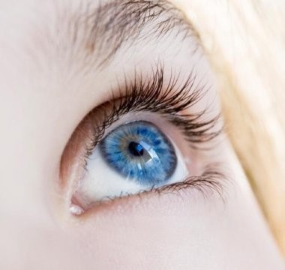

Blue-eyed humans have a single, common ancestor
January 31, 2008 University of Copenhagen

Variation in the color of the eyes from brown to green can all be explained by the amount of melanin in the iris, but blue-eyed individuals only have a small degree of variation in the amount of melanin in their eyes.
Credit: iStockphoto/Cristian Ardelean
New research shows that people with blue eyes have a single, common ancestor. A team at the University of Copenhagen have tracked down a genetic mutation which took place 6-10,000 years ago and is the cause of the eye color of all blue-eyed humans alive on the planet today.
What is the genetic mutation?
"Originally, we all had brown eyes," said Professor Hans Eiberg from the Department of Cellular and Molecular Medicine. "But a genetic mutation affecting the OCA2 gene in our chromosomes resulted in the creation of a "switch," which literally "turned off" the ability to produce brown eyes." The OCA2 gene codes for the so-called P protein, which is involved in the production of melanin, the pigment that gives color to our hair, eyes and skin. The "switch," which is located in the gene adjacent to OCA2 does not, however, turn off the gene entirely, but rather limits its action to reducing the production of melanin in the iris -- effectively "diluting" brown eyes to blue. The switch's effect on OCA2 is very specific therefore. If the OCA2 gene had been completely destroyed or turned off, human beings would be without melanin in their hair, eyes or skin color -- a condition known as albinism.
Limited genetic variation
Variation in the color of the eyes from brown to green can all be explained by the amount of melanin in the iris, but blue-eyed individuals only have a small degree of variation in the amount of melanin in their eyes. "From this we can conclude that all blue-eyed individuals are linked to the same ancestor," says Professor Eiberg. "They have all inherited the same switch at exactly the same spot in their DNA." Brown-eyed individuals, by contrast, have considerable individual variation in the area of their DNA that controls melanin production.
Professor Eiberg and his team examined mitochondrial DNA and compared the eye color of blue-eyed individuals in countries as diverse as Jordan, Denmark and Turkey. His findings are the latest in a decade of genetic research, which began in 1996, when Professor Eiberg first implicated the OCA2 gene as being responsible for eye color.
Nature shuffles our genes
The mutation of brown eyes to blue represents neither a positive nor a negative mutation. It is one of several mutations such as hair color, baldness, freckles and beauty spots, which neither increases nor reduces a human's chance of survival. As Professor Eiberg says, "it simply shows that nature is constantly shuffling the human genome, creating a genetic cocktail of human chromosomes and trying out different changes as it does so."

Student Worksheet- Blue-eyed humans have a single common ancestor Article
(source: Science Daily www.sciencedaily.com/releases/2008/01/080130170343.htm)

Text-Dependent Questions

- What claim does the author make in this article?
________________________________________________________________________________________________________________________________________________________________________

- What causes some eyes to be blue and other green to brown?
________________________________________________________________________________________________________________________________________________________________________

- How did blue eyes develop? ________________________________________________________________________________________________________________________________________________________________________

- How would completely destroying or turning off the OCA2 gene affect a person?
________________________________________________________________________________________________________________________________________________________________________

- What lead scientist, Professor Eiberg, and his team to this claim?
________________________________________________________________________________________________________________________________________________________________________
________________________________________________________________________________________________________________________________________________________________________

- True/False: The genetic mutation for hair color, baldness, freckles, eye color, and beauty spots can increase or decrease your chance of survival.

