Name :_____________________________________________________ PD:________________________________________ Date:___________________________________________

**Story of the Beaks ---Darwin’s Finches Beak Examination**

[**https://www.classzone.com/books/ml_science_share/vis_sim/lotm05_pg7_finch/lotm05_pg7_finch.swf**](https://www.classzone.com/books/ml_science_share/vis_sim/lotm05_pg7_finch/lotm05_pg7_finch.swf)

**(The above link DOESN’T work in CHROME.)**

**I. Pre-Lab:** *Predict which bird beak is most suited for the type of food by writing the number in the correct box.*

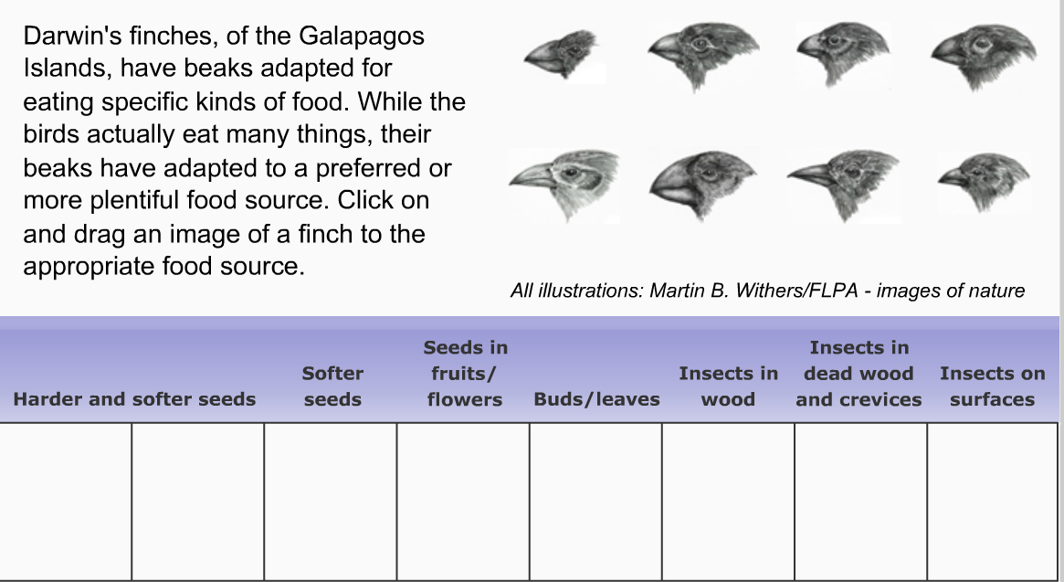

1

2

**PRELAB**

6

5

3

8

7

4

**Post-LAB #1**

**POST-LAB #1**

8

7

4

**II. Lab Activity:** *Go to the website using the web browser “EDGE” or “INTERNET EXPLORER” via teacher website.*

*Complete the simulation.*

**III. Post-Lab #1**: *After completing the simulation. Record the number of the beak that eats each type of food in the table.*

**IV: Post-Lab #2:** *Below describe what make the beak best suited for the food type.*

Beak 1 _____________________________________________________________________________________________________________________________

___________________________________________________________________________________________________________________________________

Beak 2 _____________________________________________________________________________________________________________________________

___________________________________________________________________________________________________________________________________

Beak 3 _____________________________________________________________________________________________________________________________

___________________________________________________________________________________________________________________________________

Beak 4 _____________________________________________________________________________________________________________________________

___________________________________________________________________________________________________________________________________

Beak 5 _____________________________________________________________________________________________________________________________

___________________________________________________________________________________________________________________________________

Beak 6 _____________________________________________________________________________________________________________________________

___________________________________________________________________________________________________________________________________

Beak 7 _____________________________________________________________________________________________________________________________

___________________________________________________________________________________________________________________________________

Beak 8 _____________________________________________________________________________________________________________________________