Lab 1 - Part 1
PROBABILITY:
A THEORETICAL CALCULATION
In this activity, you will discover the possibility of seeing certain species while hiking in Maryland and in the rain forest.
Definitions you will need to know:
Organism: a living being
Species: organisms belonging to a specific category
Probability: the likelihood that something will happen. It can be written as a fraction.

Outcome: the result

In this activity, each bead represents an organism and each color represents a species. Let’s look at an example. Carefully pour the Maryland species onto a surface. Count the total number of beads (organisms). There are 60. 60 is the total number of possible outcomes (total possibilities). Now, count the number of light teal beads.

These represent the species White Oak. There are 20 light teal beads. 20 is the favorable outcome(chance).
You can make a ratio with these two numbers: PARTIAL 20 1
TOTAL 60 3
The probability you will see a White Oak on your hike is or a (1 in 3) chance you will see a White Oak.

Directions: You are hiking through a forest in Maryland. To symbolize this, carefully pour the Maryland species onto a surface. On your hike, you will probably see certain species. To discover the probability of seeing White Oaks, Eastern Gray Squirrels and White-Tailed Deer, fill in the chart. The first one is done for you.
White-Tailed Deer (light pink)
Eastern Gray Squirrel (yellow)
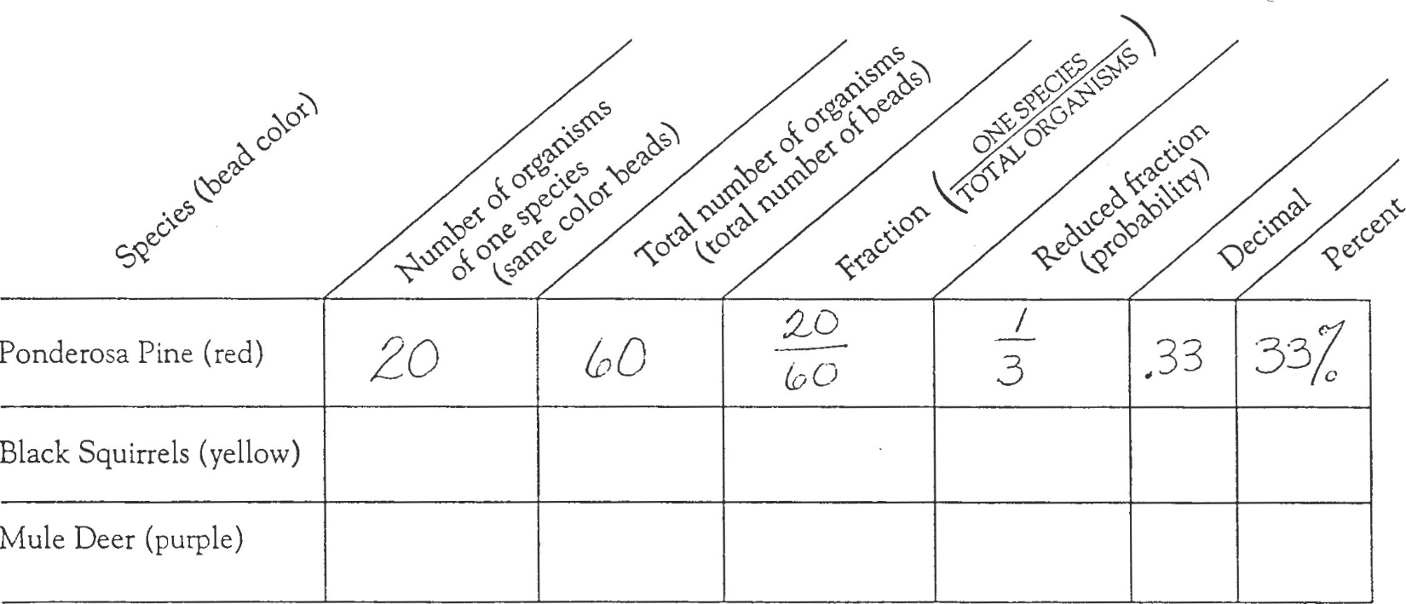
White Oak (light teal)
*How many different species in Maryland? ______________________
*How many individual organisms are in Maryland? ______________________
Directions: Put the Maryland organisms back into their clear snack container and repeat the exercise with the rain forest organisms. Fill in the chart.
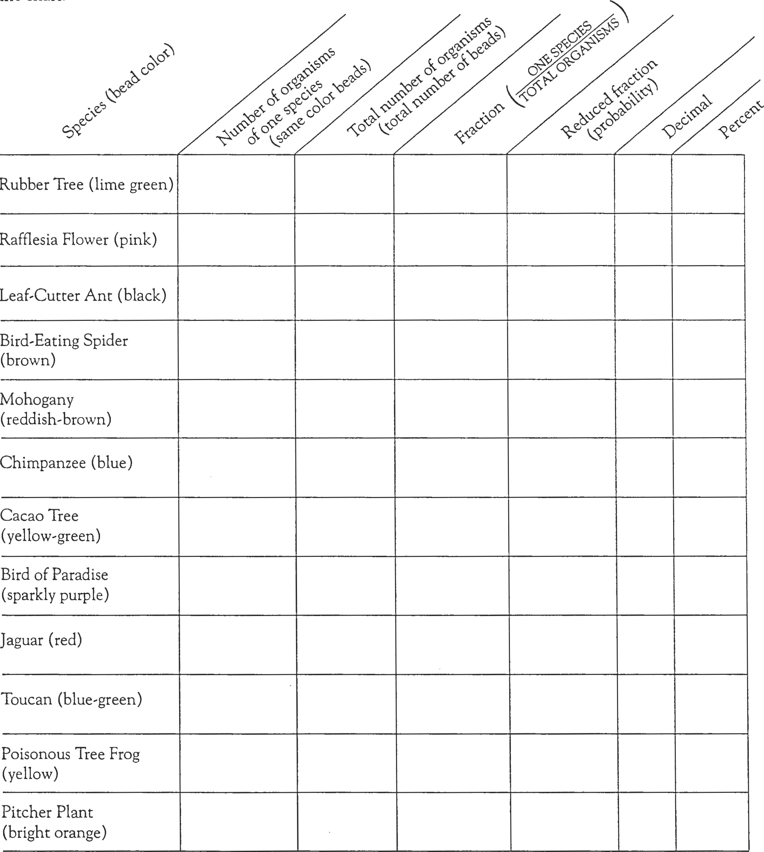
Toucan (light purple)
Cacao Tree (blue-green)
Pygmy Marmoset (blue)
Mahogany (brown)
Bird-Eating Spider (white)

*How many different species in the rain forest? ______________________
*How many individual organisms are in the rain forest? ______________________
*Which has more ecosystem has more individual organisms? _______________________
*Which ecosystem has greater biodiversity? _______________________
Lab 1 -Part II
DEFORESTATION: AN IMMEDIATE PROBLEM
The following activity will help you understand why people are so concerned over deforestation in the rain forest. Remember that each bead represents an organism and each color represents a species. Now we're adding something new to our model- the egg carton represents a 1200 square km forest (each section = 100 square km).
Carefully pour the Maryland organisms into the forest. (It doesn't matter if you get an unequal number in the sections- you will!) Roll the dice 4 times. Each time, remove the beads from the section labeled with the number you rolled. You have just "deforested" that many sections of forest, destroying the organisms that live in them.
Recalculate your number of organisms and the probability you would see on a walk after deforestation.
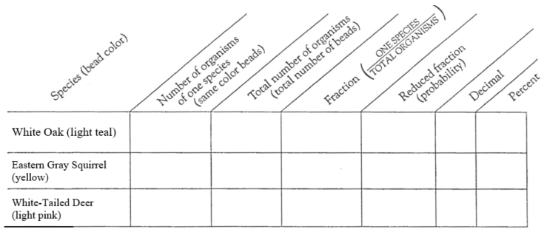Questions:
A) How many individual organisms in the Maryland forest did you kill? ___________________
B) How many organisms of each species are left in the remaining Maryland forested area?

C) Did you cause any extinctions in the Maryland forest? (eliminate one species?) _________
D) Did you impact the biodiversity of the Maryland forest? ___________

Put the Maryland organisms back in the clear snack container and repeat the exercise with the rain forest organisms. Carefully pour the rain forest organisms into the forest. (It doesn't matter if you get an unequal number in the sections- you will!) Roll the dice 4 times. Each time, remove the beads from the section labeled with the number you rolled. You have just "deforested" that many sections of forest, destroying the organisms that live in them.
Recalculate your number of organisms and the probability you would see on a walk after deforestation.
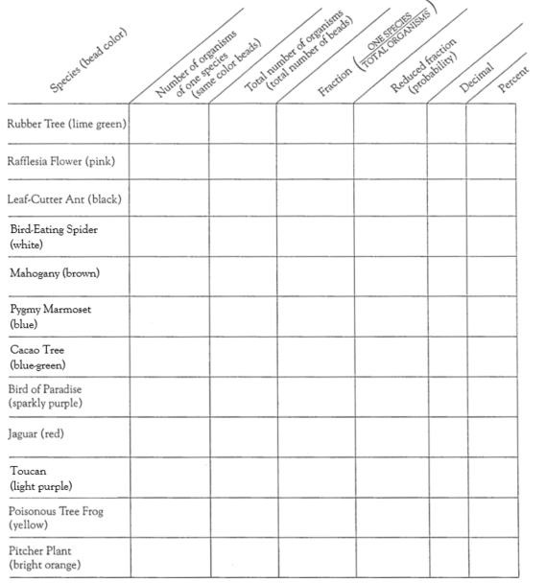
Questions:
D) How many individual organisms in the rain forest did you kill? ___________________
E) How many organisms of each species are left in the remaining rain forest forested area?

F) Did you cause any extinctions in the rain forest? (eliminate one species?) _______
G) Did you impact the biodiversity of the Maryland forest? ___________
Conclusion:
Since the rain forest has greater variation than Maryland in the species that live there, we say it has greater biodiversity. With this in mind, is there a difference between losing a section of rain forest compared to losing a section of forest in Maryland? (Create a CER response)

