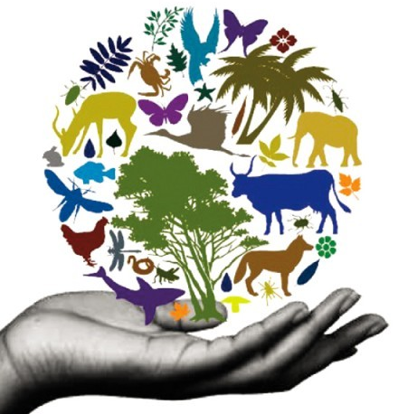
Why Biodiversity And The Interconnected Web of Life Are Important

Biological diversity, called biodiversity for short, is a deceptively simple term representing the dazzling array of Earth’s life in all its forms and interactions. Presently, scientists have cataloged about 1.8 million species from single celled organisms up to massive whales. That’s a huge library of life, but there are millions more species yet to be discovered and named. Despite biodiversity’s vastness, it’s sensitive to the pressures humans exert and is truly fragile.
The vast web of biodiversity connects all of life in various ways. Pull on one strand of the hypothetical web and several others are affected. For instance, animals like bees, birds and bats are important to the pollination of flowering plants. Remove or reduce these animals and the plants could suffer. This in turn affects us humans since about 30 percent of our crops rely on pollinators. These crops in turn give us our food, fibers for our clothes, and even fuel. Plants are the source of at least 25 percent of the prescription medicines distributed in the United States.
When droughts or floods strike, biodiversity can take the edge off of their severity. For instance, wetlands along the Mississippi river can store two months’ worth of floodwater. According to the U.S. Department of State’s Bureau of International Information Programs: “Even the finest wetlands, however, will ultimately be degraded or destroyed if too much pollution, silt, and non-native species are sent their way from upstream.”
Biodiversity can be broken down into three levels and viewed as a pyramid. Forming the base of the pyramid is the first level: genetic diversity. It comprises genetic variation within a population and between populations. For instance, in a population of rabbits found in a North Carolina forest there should be a variety of sizes, fur colors, tolerance for various diseases, etc. Also, there should be a clear difference between North Carolina rabbits and Canadian rabbits.
A population’s overall fitness could be seriously reduced if this genetic diversity narrows. According to the U.S. Environmental Protection Agency’s Ecological Exposure Research Division: “In the long term, it reduces the population’s resilience because the population’s genetic pool of potential responses to stress is restricted.” Genetic diversity is so important that the other biodiversity levels could collapse without it.
The next level up is species diversity: the variety of species in an ecosystem, which is referred to as the “species richness.” If one species is knocked out of an ecosystem, it could leave a gap that can’t be filled, such as the case with many freshwater fishes that are disappearing at an alarming rate. Those missing fish might have eaten a certain type of plant, keeping that plant’s growth in check. Without the fish, though, that plant might grow out of control and choke out other life in its lake. Also, predatory birds that depended on that fish for food would likely suffer in their absence.
Finally, the tip of the biodiversity pyramid is ecosystem diversity. This refers to the interrelated patchwork of natural communities, such as rivers, swamps, wetlands, and grasslands. If species are lost from an ecosystem, the effects can be far-reaching beyond just that one ecosystem. For example, reduced numbers of phytoplankton might contribute to more a pronounced global greenhouse effect over time.
The potential for a severe domino effect should any of the three biodiversity levels crash would be devastating. Life’s ability to persevere in the face of catastrophic events – such as a meteor strike or global climate change – can only be attributed to biodiversity’s large pool of diverse tools. It’s not an overstatement to say that without biodiversity life on Earth would not be possible. Discussion and Feedback
http://www.thebluedotpost.com/why-biodiversity-and-the-interconnected-web-of-life-are-... 10/27/2017

