Chesapeake Bay health worsened in 2018 for the first time in a decade, report says
By Tamara Dietrich
Staff writer
Jan 8, 2019 Updated 1 hr. ago
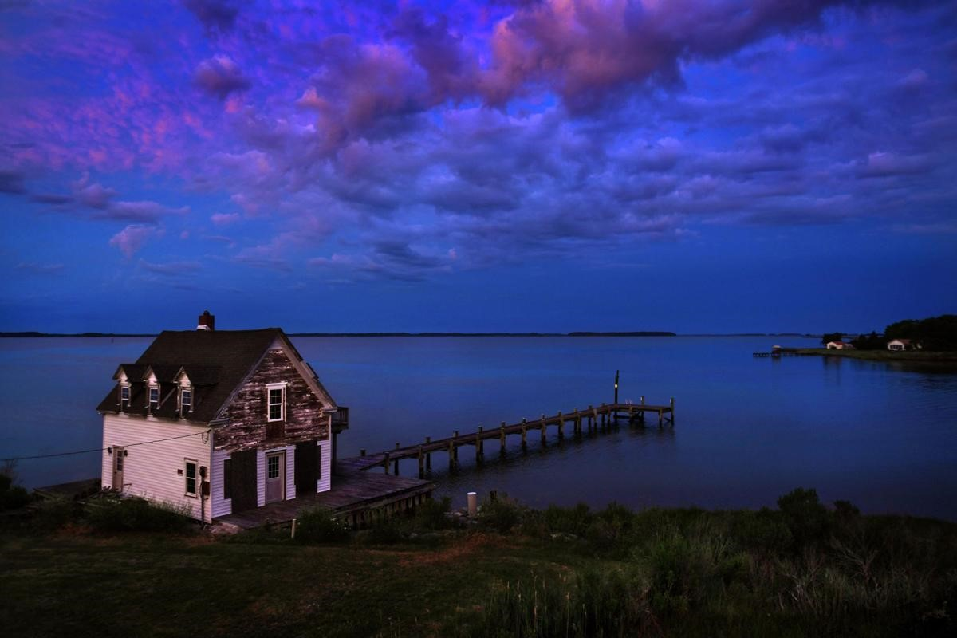
Michael S. Williamson/The Washington Post
Shown is a boarded up home with pier on the Chesapeake Bay on Hooper's Island in Maryland.
For the first time in a decade, the overall health of the Chesapeake Bay declined, dropping from a C- to a D+ in an annual State of the Bay report issued Monday.
Culprits in the decline include increased runoff from rainstorms in 2018 that were rendered more intense by a changing climate and continued failure in some jurisdictions to curb nutrient and sediment loads.
This is especially true in Pennsylvania, which consistently fails to meet most of its bay cleanup commitments, and where the chronically polluted Susquehanna River delivers half the bay’s freshwater.
“Simply put, the bay suffered a massive assault in 2018,” Will Baker, president of the Chesapeake Bay Foundation, told reporters. “The bay’s sustained improvement was reversed in 2018, exposing just how fragile the recovery is.”
Adding to the assault, Baker said, are plans by the Trump administration to roll back clean water and clean air regulations that will directly impact the watershed.
Trump plans to overturn an Obama-era rule and reduce federal oversight for vast sections of the nation’s waterways and wetlands, and also ease federal restrictions for coal-fired power plant emissions. About a third of the nitrogen that reaches the bay comes from airborne sources, said Baker, some from as far away as the Midwest.
The CBF assesses bay health every year by looking at 13 indicators in three categories — pollution, habitat and fisheries.
“While some indicators improved or stayed the same,” CBF chief scientist Beth McGee said Monday, “scores for the bay’s two systemic pollutants — nitrogen and phosphorus — decreased substantially, reflecting increased loads caused by the high rainfall in 2018 and above-average loads in 2017.” And rain-heavy years may no longer be outliers, CBF says, but a new normal.
Nitrogen and phosphorus are dumped into the 64,000-square-mile watershed through runoff, chiefly from agricultural lands and wastewater, although Baker said the “airshed” that delivers nitrogen to the bay is about nine times that size.
“So air pollution and water pollution really need to be thought of as simply two sides of the same coin,” Baker said.
The report does include some good news: The bay is showing some surprising resilience that could help it overcome long-term damage, especially regarding underwater grasses and low-oxygen dead zones.
Scientists discovered some of that resilience last August when they visited underwater grass beds on the Susquehanna Flats and elsewhere in the watershed.
“What they were seeing is some injury around the fringes of the grass beds, but when they went to the middle, the water was clear, and the grasses seemed robust,” McGee said.
Underwater grasses provide essential habitat for the bay’s iconic blue crab and other marine species, as well as improve water clarity.
Scientists also found the bay showing some surprising success in countering dead zones.
Dead zones are fueled by the nutrients in runoff. Because spring rainfall was so heavy the last two years, scientists had expected to see bigger dead zones in the summer.
Instead, the bay’s dead zone in 2017 was the second-smallest on record, while last year’s was average.
Winds could have helped reduce the size of the zones, the report states, but a recent study by the
University of Maryland indicates the bay may actually be “starting to help itself.”
A change in the feedback loop in the bay’s bottom waters is apparently churning up nutrients, leaving less fuel to create dead zones and more oxygen for the marine creatures living there.
Fisheries showed a mixed bag. Rockfish and blue crabs maintained their healthy levels, while oysters and American shad populations continue to do poorly, both earning Fs in the report.
The dismal oyster score reflects a continued low in the combined wild fishery harvest in Virginia and Maryland, even as the aquaculture industry continues to thrive. Maryland’s wild harvest dropped nearly 45 percent in 2016 and 2017, although Virginia’s total harvest has remained stable for the past several years at about 600,000 bushels annually.
Shad numbers are low overall. But in Virginia, the Pamunkey River, which has been used to harvest broodstock, has seen a decline in the number of returning adults, while budget cuts and low returns have led to no shad stocking in the James for the first time in more than two decades.
The State of the Bay measures the waterway against the pristine conditions English explorer Capt. John Smith encountered in the early 1600s. It ranks indicators on a scale of 1 to 100, with 100 being Smith’s ideal bay.
The CBF concedes the Chesapeake will likely never hit those highs again but considers an overall score of 70 by the year 2050 an achievable goal.
The bay’s current ranking is 33, a one-point drop from last year.
Grades in the report include:
Pollution — nitrogen, phosphorus and water clarity all Fs; dissolved oxygen C and toxics D.
Habitat — Forested buffers B; wetlands C; underwater grasses D; resource lands D+;
Fisheries — Rockfish A-; blue crabs B; oysters and shad Fs.
To read the report, go to www.cbf.org/stateofthebay.

Tamara Dietrich

