Climate Change in Alaska
By: U.S. Environmental Protection Agency, adapted by Newsela staff on 04.04.17
Word Count 1,016 Level 1040L Climate change affects the habitat of many animals, such as polar bears, in Alaska. Photo by: Susanne Miller/USFWS
Overview
Alaska is the largest state in the United States. It makes up about 20 percent of the total area of the country, more than twice the size of Texas. Alaska has lands inside the Arctic Circle. It has rain forests, glaciers, tundra, peatlands and meadows. Alaska contains 16 national wildlife refuges spanning 76 million acres and includes the largest U.S. national park.
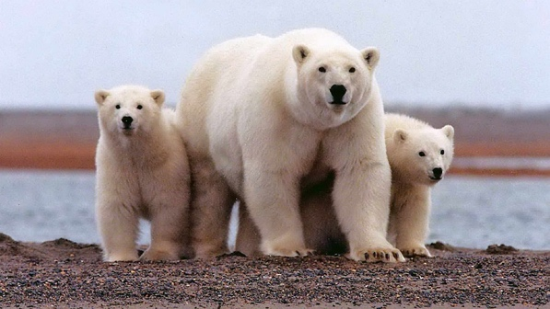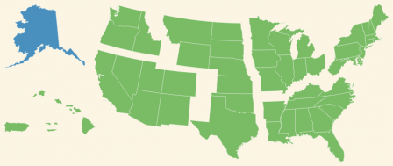

Over the past 60 years, the average temperature across Alaska has increased by approximately 3 degrees Fahrenheit. That is more than twice the warming seen in the rest of the United States. Warming in the winter has increased by an average of 6 degrees and has led to changes in ecosystems. Average annual temperatures in Alaska are projected to increase another 2 to 4 degrees by the middle of this century. Rain and snow in Alaska are projected to increase, but the state is likely to become drier due to greater evaporation. Rising temperatures may provide some benefits in Alaska, but climate change is also hurting many people, ecosystems and species.
Permafrost
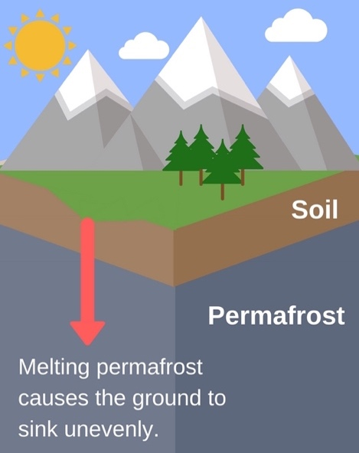

Permafrost is frozen ground located a few feet below the soil surface in extremely cold regions. Eighty percent of Alaska's surface lies above permafrost. Permafrost typically remains frozen year-round. As air temperatures rise, though, permafrost is thawing in many areas. As it thaws, the soil above can sink, damaging roads, homes and other structures. Melting permafrost will effect transportation, forests, other ecosystems and business in Alaska.
Transportation And Infrastructure Impacts
The thawing of permafrost can potentially damage roads and other infrastructure in Alaska. Uneven sinking of the ground makes fixing them expensive. Many of Alaska's highways are built in permafrost areas. They are in danger if the permafrost thaws.
Ecosystem
Lakes in Alaska are changing. Surface waters and wetlands provide breeding habitat for millions of birds that spend winter in the lower 48 states. These wetland ecosystems and wildlife are also important to Alaska Natives who hunt and fish for food.
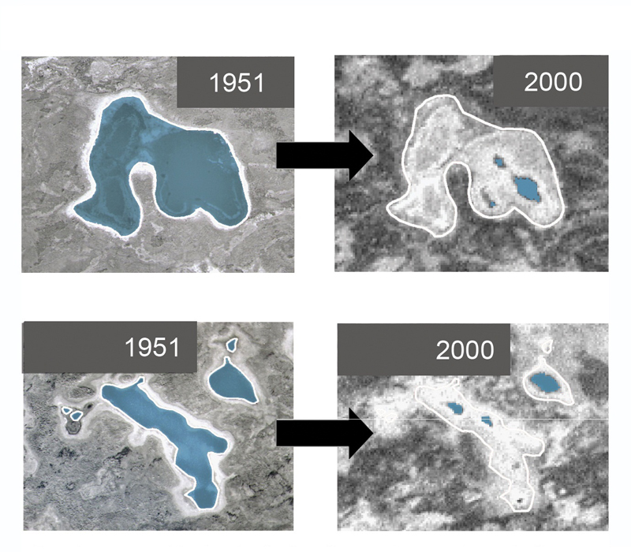

Many factors are causing lakes to get smaller. Warmer temperatures increase evaporation. When permafrost thaws, the lakes can drain more easily. Decomposing plants also build up on lake bottoms, caused by greater plant growth. In areas where permafrost is broken up, lakes are expected to continue shrinking.
Some lakes are growing. The edges of the lake collapse inward, increasing the area of the lake. Lake growth is expected to continue in areas with continuous permafrost.
As the climate warms, shrubs are expanding into the tundra, replacing other plants that caribou eat, like lichens. The loss of lichens means caribou go hungry and die. Bears, wolves and even people depend on caribou for food.
Higher temperatures and drier conditions increase the risks of drought, wildfire and insect infestation. Large wildfires have consumed more forest in Alaska in the last 10 years than in any other 10-year span. The area burned annually is projected to double by 2050. Fires
change forest habitat, improving conditions for moose and some plant species, but reducing the lichen that caribou rely on in winter. Warmer temperatures are also expected to worsen insect damage to forests. That increases the amount of dead, highly flammable trees.
Oceans And Coasts
Sea ice is frozen seawater that floats on the surface of the ocean. Some sea ice persists from year to year, known as perennial sea ice. It often gets thicker as it piles up against Arctic shorelines. Other sea ice is seasonal, melting during the summer and refreezing in winter.
Perennial sea ice is declining as a result of warmer temperatures, ocean currents and wind patterns. September 2012 had the lowest area of ocean covered by ice on record, just half as much as usual. Climate models project that sea ice will continue to decrease. The Arctic could be nearly ice free during the late summer by the 2030s.
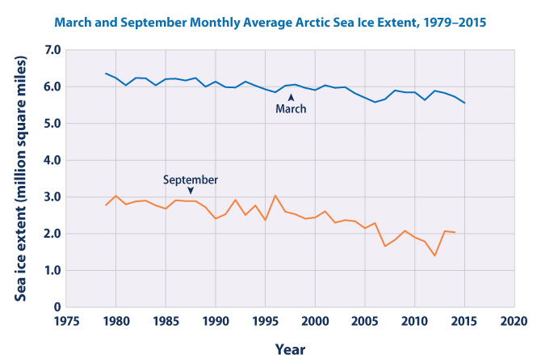
Diminishing sea ice is opening new opportunities for shipping, tourism, and other economic activities. However, it also creates a pathway for invasive species and habitat loss for animals that depend on ice, like walruses and polar bears.
Sea ice along the shoreline and permafrost in coastal areas help to protect human settlements from flooding and erosion. Declining sea ice increases coast erosion. Residents are less protected as a result.

Alaska's Natives
Alaska is home to 229 federally recognized tribes. They are already experiencing the effects of climate change. Alaska Native peoples depend on fishing and hunting animals. As the animal populations decline, some people have to travel onto thinning ice in search of food and are being forced to seek alternative food sources. Arctic plants and animals are also at higher risk for diseases, further affecting food availability and human health.
Intense extreme weather events are also increasing erosion and flooding along Alaska's northwestern coast. More than 30 Native villages have had to relocate their entire village. However, this is expensive and difficult. Tribal communities in Alaska have had a hard time relocating to safer areas.
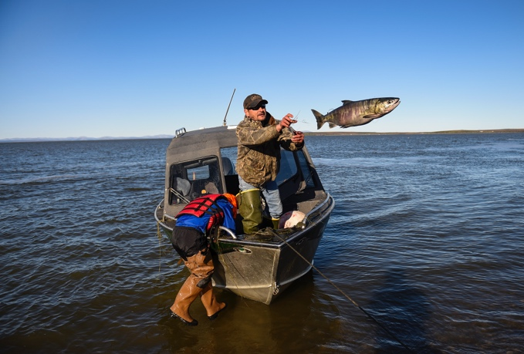
Quiz
- Which paragraph in the section "Oceans And Coasts" presents potential benefits of climate change in Alaska?

- Which section of the article explains HOW climate change can cause opposite effects in similar areas?
(A) "Overview"
(B) "Permafrost"
(C) "Ecosystem"
(D) "Oceans And Coasts"
- Which of the graphics from the article BEST reflects the idea that the effects of climate change will likely cause problems in Alaska?
  - (A) the permafrost graphic
  - (B) the ponds image
  - (C) the sea ice chart
  - (D) the fishing photograph

- Look at the chart titled "March and September Monthly Average Arctic Sea Ice Extent, 1979-2015." Which of the following conclusions is BEST supported by information in the chart and the article?
- (A) Dwindling sea ice presents challenges for Alaska Natives.
- (B) Melting permafrost contributes to the increased decline of sea ice.
- (C) As sea ice continues to melt, wildfires will become less of a concern in Alaska.
- (D) Although decreased sea ice harms many animals, the effects on people are mainly beneficial.

