COMEBACK OF AQUATIC GRASSES IN CHESAPEAKE CREDITED TO DECADES OF EFFORTS TO REDUCE NUTRIENT POLLUTION

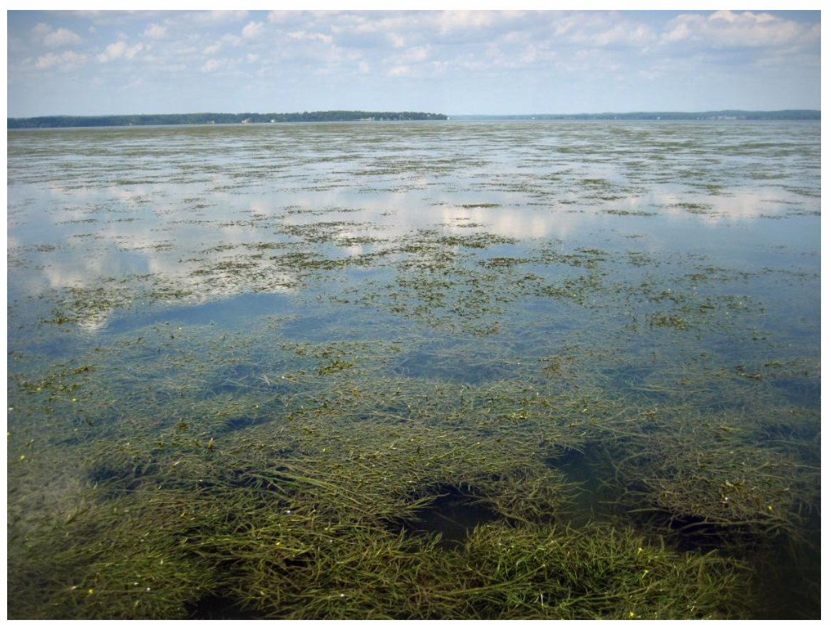
March 5, 2018
According to a new study, the resurgence of aquatic grasses in Chesapeake Bay is the result of decades of efforts to reduce nutrient pollution. Seen here, the Susquehanna Flats in the upper Bay near Havre de Grace.

This past September, underwater grasses began to appear off shore from the University of Maryland Center for Environmental Science’s Chesapeake Biological Laboratory in southern Maryland. The marine research campus has occupied this peninsula in Solomons, where the Patuxent River flows to meet the Chesapeake Bay, since 1925. The grasses haven’t been seen here since 1972. Their comeback after 45 years signals a major positive shift in the health of the Chesapeake Bay.
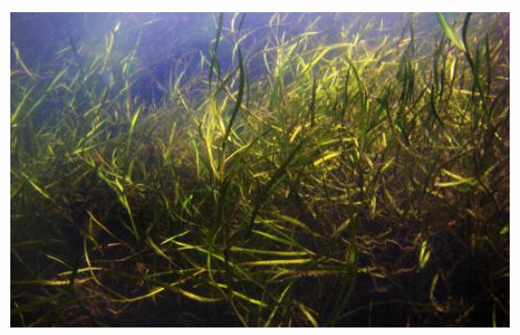
“We’re very glad to report the largest resurgence of aquatic grasses due to management actions ever recorded, right here in Chesapeake Bay,” said co-author Bill Dennison, Vice President for Science Applications at the University of Maryland Center for Environmental Science.
A resurgence of submerged aquatic vegetation is the result of decades of efforts to reduce nutrient pollution in the Chesapeake Bay.

According to a new study, the resurgence of grasses here—and similar recent comebacks seen throughout out the estuary in recent years—are the direct result of decades of efforts to reduce nutrient pollution in the Chesapeake Bay. An analysis of more than 30 years of data shows that sustained management actions over the past two decades have reduced nutrient pollution in the Chesapeake by 23% since 1984 and have led to a resurgence of ecologically and economically important aquatic grasses. Underwater grasses, also known as submerged aquatic vegetation (SAV), have regained 17,000 hectares to achieve the highest cover in almost half a century.
“What emerged from that analysis is that this nutrient diet is starting to pay real dividends in the resurgence of grasses around the bay,” said Dennison. “We’re been calling these grasses our coastal canaries, the things that are most sensitive to water quality degradation, and the things we have to watch as long-term indicators of these water quality situations.”
Aquatic grasses are known as a sentinel species, an indicator of broader ecological function or an early warning of ecological impairment. They are important ecologically, providing habitat for baby crabs and other creatures while protecting shorelines and stabilizing sediments so that erosion is minimized. They are also important economically since they are home for commercial species such as blue crab, silver perch, and striped bass.
Since 1950, the population of the Chesapeake Bay has doubled, leading to changes in land use and adding to the substantial nutrient and sediment runoff from both urban and agricultural lands. Increasing nutrient inputs fueled algal growth in the water that prevented light from reaching the bay grasses, which grow along the Bay’s bottom. These conditions also favored the growth of algae that grow on the leaves of the bay grasses themselves, further shading them from light. Tens of thousands of hectares of SAV were lost, the largest decline documented in more than 400 years.
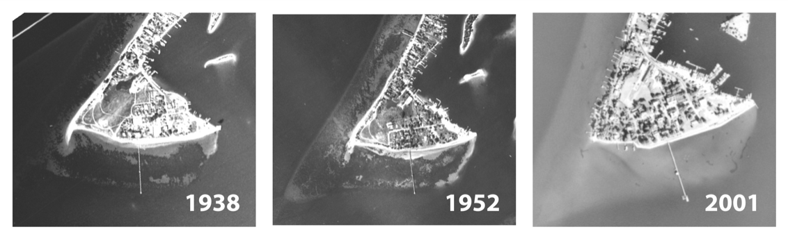
Since 1950, the population of the Chesapeake Bay has doubled, leading to changes in land use and the virtual disappearance of underwater grasses, as seen here off Solomons Island in southern Maryland.
Researchers from 10 institutions across the country analyzed 30 years of data to predict the impacts of people living near the Bay on submerged aquatic vegetation, an ecologically and economically viable habitat. The study used aerial surveys from 1984 to 2015, monitoring data, historical information on land use and fertilizer application and watershed model estimates for the loads of nutrients and sediments from land runoff and point source such as wastewater treatment plants.
The study confirmed that nutrients play a dominant role in reducing SAV cover. Long-term nutrient trends show that water column nitrogen concentrations have declined on average by 23%, and phosphorus concentrations by 8% since 1984, the biggest reductions occurring in the mid-1990s. Declining nutrient levels coincided with a 316%, or fourfold, increase in SAV cover during the same period, from 7,878 hectares in 1984 to 24,874 hectares in 2015 from aerial surveys.
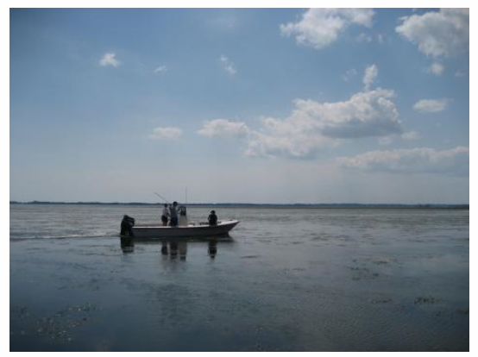
"The Chesapeake Bay has turned the corner. In fact, it’s one of the large ecosystems in the world that has probably made the most progress," said President Peter Goodwin of the University of Maryland Center for Environmental Science. "This comeback of underwater grasses reaffirms that government and stakeholders can come together to set goals and implement management actions to make an impact on a large and complex coastal ecosystem. These are sensitive indicators of the health of Chesapeake Bay, and it is important that these successful management strategies are continued.”
Susquehanna Flats, a large area of aquatic grasses in the upper Chesapeake Bay near Havre de Grace, Maryland, are a hot spot for striped bass fishing.
Concern for the overall health and economy of the Bay led to unparalleled cooperation among federal, state, local and scientific agencies whose joint efforts identified nutrient pollution and subsequent loss of SAV as the two most critical issues facing Chesapeake Bay. These agencies instituted measures to reduce nutrient inputs as well as long-term monitoring programs to gauge their effectiveness, established the Chesapeake Bay as one of the few places on Earth where comprehensive long-term data exist to link impacts and ecological restoration at broad scales.

