Eden lost - the ecological disaster of deforestation
November 15, 2018
Chris Anderson

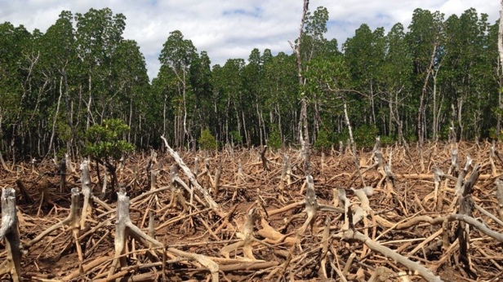Climate change grabs all the headlines, but deforestation could wipe out millions of species as well.
In 1964, Shel Silverstein’s childhood classic The Giving Tree was first published. It tells the story of a boy who takes everything a tree lovingly gives him. The boy takes apples to sell, branches to make furniture, and the trunk to make a boat until all that is left is a stump where the tree used to live. It’s a thought-provoking tale, one that has been dissected from every angle over the years. Yet the story might be at its most powerful as a metaphor for deforestation and the modern economic demands that drive it.
From the boreal forests in Siberia and Canada, temperate deciduous forests of Eastern North America and Europe, and tropical rainforests that encircle the Earth’s equator, forests occupy nearly a third of the land surface on our planet. They provide a habitat for birds, mammals, reptiles, and amphibians of all kinds and provide humans with everything from food to timber to tourism dollars. But around the world, forests are disappearing at a jaw-dropping rate. Nearly 20% of the Amazon rainforest has been cut down since The Giving Tree first hit libraries and bookstores. The equivalent of 27 soccer fields of forest is destroyed every minute, adding up to the Earth losing about 18.7 million acres of forest annually. That means an area bigger than the island of Ireland annually. This mass deforestation due to human development and agriculture has destroyed millions of acres of habitat and has put countless species at risk for extinction.

The forest through the trees
Deforestation, the large-scale destruction of forests, isn’t exactly a new problem. As Europeans began arriving to the Americas in large numbers in the 1600s, much of the virgin forest was cut down for farming. A study by the University of Michigan found that 90% of the indigenous forest in the continental United States has been cut down. But the problem has gotten much worse in the last few decades, due mostly to clearing land for agriculture and human development.
Developing countries specifically have seen most of the deforestation, where governments generally have little environmental regulation and oversight of industries. Slash and burn farming, a method by which existing vegetation is cut down and burned off, has cleared large areas of tropical rainforest, destroying habitats rich with biodiversity. However, rainforest soils are quite poor and acidic. This means that the land cleared from slashing and burning is only good for a few seasons before all the nutrients are removed and more forest must be cut down. Slash and burn farming has been greatly used in the Amazon, cutting down large parts of the rainforest for cattle ranching. Mining and logging in Central Africa and harvesting palm oil, an ingredient used in anything from cosmetics to household cleaners, in Southeast Asia, have all contributed to the massive loss of the Earth’s forest. Too often, these countries do not have the resources to oversee how industries use their natural resources.

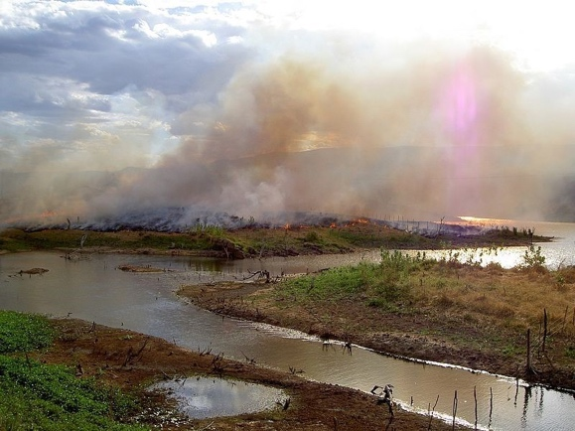
The use of slash-and-burn farming technique in Ceará, Brazil contributes to the already mass scale deforestation in the Amazonian forest. (Photo Credit: Wikipedia)

That’s not to say the problem doesn’t affect more industrialized countries. Logging, both by permit and illegally, is still responsible for millions of acres of destroyed forest each year in the United States and Canada. And several years of record forest fires have burned down millions of acres along the west coast, a trend that will only continue as global temperatures increase. Suburban sprawl, which destroyed a lot of natural habitat in the US in the second half of the 20th century, has begun to push into the last few areas of wilderness. The roads, homes, shopping centers, and highways that come with human development has not only eaten up forested land but has partitioned it, breaking up large areas into smaller fragments.As Earth’s human population continues to grow, demand for food and space increases as well, putting more pressure on the world’s remaining forests.

Cut down at the knees
Deforestation on such a massive scale is obviously a catastrophe for ecosystems around the world, but there are human costs as well. To start with, trees filter the air and water, providing people with a clean and vital resource. Cutting down forests takes away a natural filter. The complicated root systems that support trees also protect against erosion, without which makes dangerous mudslides and mass wasting more likely.
Climate change will also get worse with the current rate of deforestation. Forests act as a sink for carbon, absorbing carbon dioxide that would otherwise be in the atmosphere. As more and more trees are cut down, the carbon dioxide in the atmosphere will have no place to go, making the potentially catastrophic problem of global warming even worse. If forests are replaced with large-scale cattle ranching, it can double the warming effect on the atmosphere. Cattle ranching gives off a lot of pollution, both as surface water runoff and methane gas, a greenhouse gas that holds about 30 times more heat than carbon dioxide.
Urban expansion at the expense of forested areas will also feel the heat. Trees retain a lot of water, keeping the air around forested areas cool. When those trees are replaced with the metal and concrete of buildings and highways, cities become heat islands and can get dangerously hot in the summer. Additionally, hotter air is able to dissolve more smog and particulate matter, making air quality dangerous for the elderly and people with asthma. As cities continue to grow and climate change makes summers hotter around the world, the problem will most likely get worse.

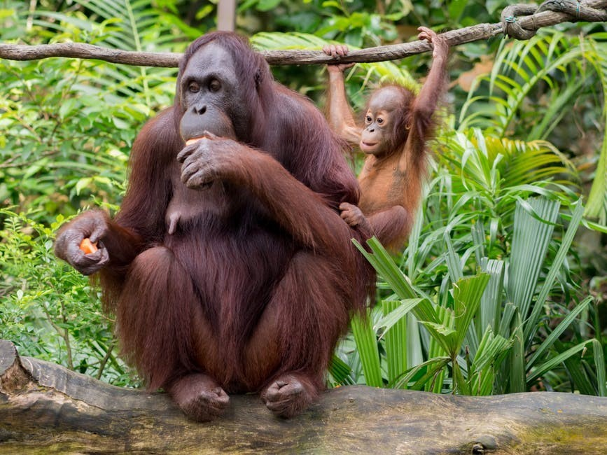

Orangutans, one of mankind’s closest relatives, is in danger of becoming extinct due to deforestation in Southeast Asia. (Photo Credit: Pexels/Brett Jordan)
But the biggest threat deforestation poses is the extinction of hundreds, if not thousands of species. Since trees provide a food source or a home for so many living things, cutting down a forest causes massive ripples throughout an ecosystem, especially in areas of high biodiversity. Over half of the tree species in the Amazon are at risk for extinction. Flying insects have seen a 75 percent decline in their populations. 41 percent of all amphibians, 25 percent of all mammals and 60 percent of primate species are endangered — all due to human activity. As more and more forests are cleared, the habitats of other species disappear, leading to losses across interconnected ecosystems. And while mass extinctions have happened throughout Earth’s history, none have been at the rate scientists are currently observing. Animals are going extinct at a pace 1,000 to 10,000 times faster than if no humans lived on Earth. Increasingly, we are coming face to face with a stark reality: humans are willing to cut down forests and destroy habitats for our own sake, even if it’s at the expense of other living things.

Planting the seed
Does this mean we are doomed to a future without forests and the living things that thrive there? Or are can humans give back to nature at least part of what we’ve taken?
Our fate might not yet be sealed. Reforestation initiatives across the world have taken on the task of restoring previously deforested land. Plant a Billion Trees, which is part of the Nature Conservancy, has ongoing reforestation projects in Brazil, China, and the US, and have already planted nearly 100 million trees. Eden Reforestation Projects have planted over 200,000 trees in Nepal, Madagascar, Haiti, Indonesia, and Ethiopia. And Conservation International is leading a project to restore 70,000 acres of the Amazon to its former glory, putting thousands of people to work in the process. You can even offset your individual carbon footprint by purchasing offsets from CarbonFund.org, where your donation is used to rebuild lost habitats.
Governments are also getting in on the action. Rwanda, whose deadly civil war ravaged the native forests, has already restored much of the cleared land, part of an Africa-wide initiative to reforest a million hectares of land across the continent. Runaway development in China led to a $100 billion investment in reforesting an area larger than New Mexico. Even cities are returning to their forested roots. Chicago, Los Angeles, Philadelphia, and Detroit are just a few US cities who have active urban greening projects. New York City has planted over 750,000 trees since 2007.

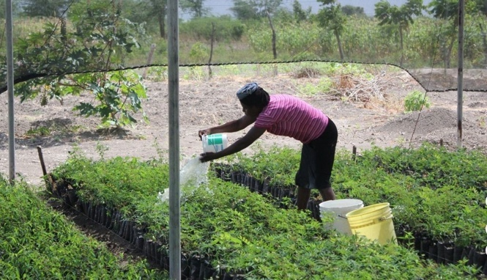

This reforestation nursery in Haiti is part of a project to reclaim habitat that has been cut down for agriculture or development. (Photo Credit: Wikipedia)

But nature is complex and simply planting more trees will not immediately fix the problem. While a lot of lands has been reforested, biodiversity in these places is still lagging. In the United States, the US Forestry Service manages land to make sure that trees are logged sustainability. However, while a tree may able to be harvested after around 20 years, forests take around 100 years to reach full maturity.
Protected and reforested areas must stay that way for decades before their full benefits and biodiversity are realized. Only a long-term commitment, one that will take multiple generations and stable environmental policy, will allow for forests to reach their healthiest. Scientists are also concerned about the rate of deforestation. Even with habitat restoration efforts, researchers estimate that there may be no rainforest left within 100 years. Deforestation, combined with climate change, could spell the end for a wide range of species.
All humans, no matter where they live, want the same thing: a clean, safe place to live and food to eat. With nearly 8 billion people living on Earth, that’s going to require a lot of space for farming and development. The reality is that there is only so much space on our planet. We’ve got to decide how much of it we’re willing to share

