Name: Date:

Student Exploration: Embryo Development

Vocabulary: embryo, embryology, fetus, zygote

Prior Knowledge Questions (Do these BEFORE using the Gizmo.)

- The images below show embryos of different species at different stages of development. Label the images below with 1-4 from least developed to most developed.
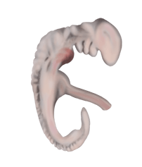
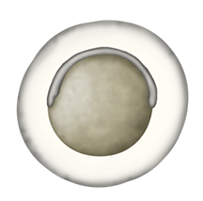
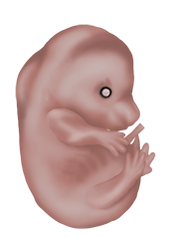

A B C D

- Which image above do you think is a human? Explain.

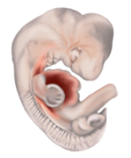

Gizmo Warm-up
Embryology is the study of the development of embryos from a single cell to a multicellular fetus. In the Embryo Development Gizmo™, you will compare the development of different animals and learn the details of mammalian development. To begin, be sure the COMPARE tab is selected.

- What do the images have in common?

Click on the check box to turn on Scale bars and labels. You are observing the zygotes, or fertilized single cells, of five animals.

- At this point, are you able to tell which animal is which? Explain.

Activity A:  Comparative embryology | Get the Gizmo ready:  - Make sure the COMPARE tab is selected and the Developmental stage slider is on stage 1.  - Turn off Scale bars and labels. | 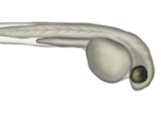

Introduction: Comparative embryology compares embryos of different species to gain insight into how they are related. To provide a framework for this comparison, embryologists divide this process into 23 Carnegie stages. You will look at seven of these stages in this activity.

Question: Can we use comparative embryology to determine the relatedness of species?

- Challenge: Drag the labels to the embryos you think they belong to. Fill in the first row of the table below with your guesses. Then, move the Developmental stage slider one position to the right, to Carnegie stage 4. Rearrange your labels if necessary and fill in the next row of the table. Continue until you get to stage 23. Don’t turn on the Reveal answers check box until the end. (Note: Your guesses may change as you go through the stages. Don’t worry, they won’t be graded - this is just for fun!)

Stage | A | B | C | D | E
1
4
8
13
16
20
23

- Reveal: Click Reveal answers.

- Did you guess correctly in the end?

- At which stage were you able to tell which was which?

Explain:

- Observe: Drag the Developmental stage slider back to stage 8. Turn on Scale bars and labels. What structure does all of the embryos have in common?
The neural groove will fold into a neural tube and will become the central nervous system.
Activity A (continued from previous page)

- Observe: Switch to stage 13. What do all of the embryos have in common at this stage?

In mammals, brachial arches develop into structures in the head and neck. In fish and frogs they become part of the jaw and structures that support the gills (and are eventually lost in frogs). Somites are blocks of tissue that divide an embryo into segments that will become part of the vertebrae. The tail bud is tissue that helps form the posterior of the animal.

- Compare: Go to stage 16.

- What structure does all five embryos have in common?

- What structures are missing from the frog and fish?

Frogs are born as limbless tadpoles and their arms and legs develop later.

- Compare: Go to stage 20. What structure does mice and humans have in common that are missing from the other organisms?

- Discuss: Looking at the similarities and differences between the organisms throughout development, which organisms are more closely and more distantly related to one another?

Explain.

- Think and discuss: How do the similarities and differences between embryos provide evidence that evolution has occurred?

