Welcome to Stomatal Count!
Ginko Trees and Citizen Science Project
https://www.zooniverse.org/projects/laurasoul/fossil-atmospheres
Directions:
- Go to https://www.zooniverse.org/projects/laurasoul/fossil-atmospheres
- Click on “About” and complete the questions on worksheet.
- Register as a participant. (Use your personal email.)
- Go to practice count. Complete one at a time and compare your results with the expert results under the “field guide” tab. (To get to “PRACTICE COUNT”, you may need to click on the “FOSSIL ATMOSPHERES” check.
They will show you microscope images of the surface of leaves. You need to identify and mark two different types of cell.
Step 1) The first cells that you will be counting are stomata. One stoma is made up of two sausage shaped cells (guard cells) either side of a small opening. Mark each stoma once only.
- Only mark Stomata that are at least partly inside the white box.
- But do mark even the ones that have only a tiny part within the white box.
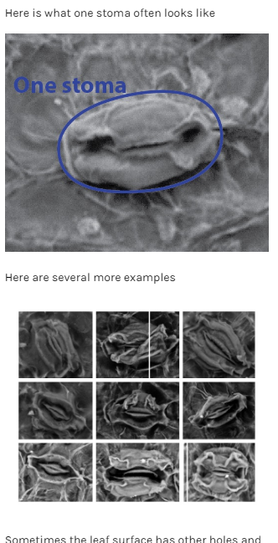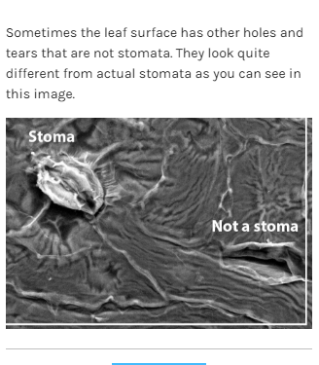

Step 2) The other feature we want you to count are the normal leaf cells, which make up all of the rest of the image. Just look for the raised boundaries enclosing each cell, with some darker depressions in the middle.
- Only mark normal cells that are at least partly inside the white box.
- But do mark even the ones that have only a tiny part within the white box.
- These cells come in many shapes and sizes. In the examples below, we marked all of the normal cells in blue to give you an idea of what you're looking to find. There are many more examples in the field guide.
- Some cells only have one depression, others have several, it's the cell boundary you're really looking for.
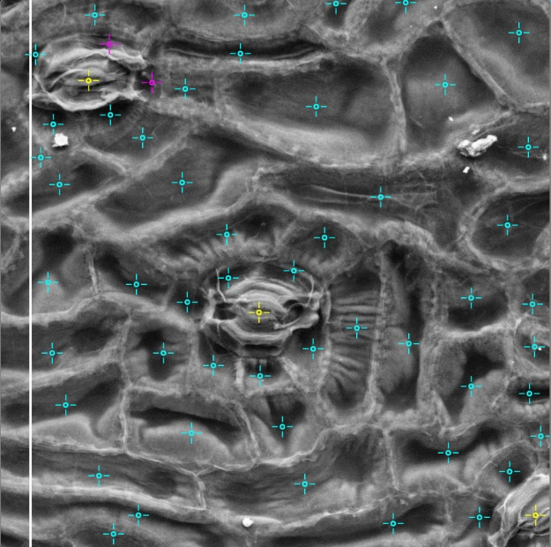

Remember, lots of people will be looking at every image so it won't matter if you miss a few!
Do your best to mark every cell
If you get stuck:
- Click the help button
- Look in the field guide
- Look in the FAQ
- Post on the talk board

After practice, you will go to the real images.
Image # | Your Stomata Count | Your Epidermal (normal) cells | Expert Dr. Rich’s Stomata count | Expert Dr. Rich’s Stomata Count
1
2
3
4
5

Teacher has review my practice data: _____________________________________________ (teacher sign)

