How Dinosaurs Swapped Terrifying Teeth for Bird Beaks
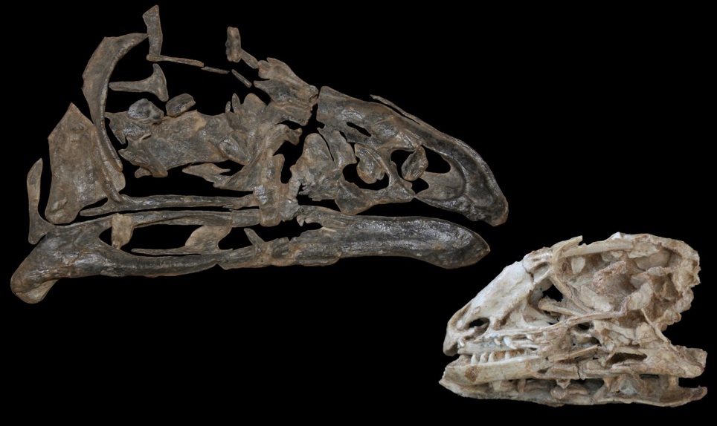
The Limusaurus, a theropod that had teeth in its youth — the skull on the right — but then lost them as it grew into an adult, left, developing a beak instead. Credit Josef Stiegler
The world once trembled before the theropods.
This dinosaur group, which included bloodthirsty killing-machines like the Tyrannosaurus rex and velociraptor, was notorious for sharp, serrated teeth that many used to eviscerate prey and strip flesh clean from bones. But over millions of years, the fearsome beasts evolved into today’s flamboyantly feathered birds, replacing their terrifying teeth with beaks.
How the theropod mouth transformed has long been a mystery, but a study published Monday in the Proceedings of the National Academy of Sciences provides insight into a potential evolutionary mechanism behind the transition.
Amy Balanoff, an evolutionary biologist from Johns Hopkins and an author of the paper, described the findings as further “evidence showing the line of evolution from a Tyrannosaurus rex to a pigeon.”
Photo
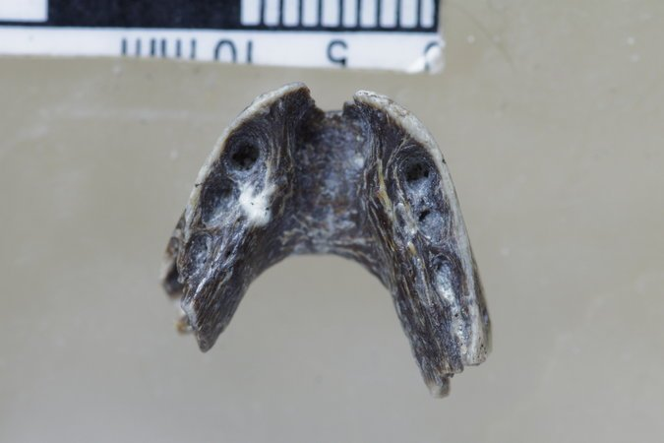
A fossil jaw from the early Cretaceous bird Sapeornis showing vestigial tooth holes. Credit Hailong Zang
Using fossils and a large comparative analysis of modern animals, Dr. Balanoff and a team of evolutionary biologists, led by Shuo Wang from the Capital Normal University in Beijing, found that the loss of teeth and the emergence of beaks are connected processes in theropods. As the beak grew across the dinosaur’s face, it also inhibited the growth of teeth, the team suggested. On an evolutionary scale this transition happened until theropods developed mouths that resembled the bird beaks seen today.
In earlier research, Dr. Wang’s team discovered an emu-like theropod called Limusaurus that began life as a baby with teeth, but lost them as it grew older and morphed into an adult with a beak.
For their most recent paper, he and his colleagues examined more dinosaur jaw fossils and found two other theropods that underwent transitions similar to Limusaurus: an early Cretaceous bird called Sapeornis, which resembled modern birds, and a small caenagnathid oviraptorosaur, which resembled a velociraptor but with a beak.
“This demonstrates an evolutionary process of the beak for the first time,” said Dr. Wang.
All three theropods had beaks but with vestigial, or functionless, tooth sockets.
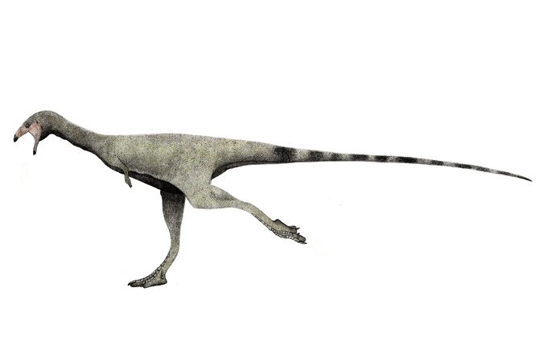
A rendering of the Limusaurus. Credit Levi bernardo, via Wikimedia Commons
“Based on these three dinosaurs, we now have evidence for three distinctly different lineages that lose their teeth during postnatal development to have a beak,” said Josef Stiegler, a doctoral candidate at the George Washington University in D.C. He added, that the findings suggest there may be more examples in the fossil record.
After collecting the fossil evidence, the team sought further support for their hypothesis that the processes of teeth loss and beak development were connected. So they performed a comparative and statistical analysis of thousands of modern vertebrates to understand the shared characteristics of animals that develop beaks.
They found that beaked animals tended to be born from eggs laid on land and from embryos that had a structure on the tip of their snouts known as a caruncle. The facial structure was made of keratin, the substance found in fingernails, and was used to break through the egg before falling off shortly after. Beaked groups like birds and turtles have caruncles, but snakes and nearly all lizards do not.
Mr. Stiegler linked their analysis to what they found in the fossil record. He said the transition they saw in the jaws of the Limusaurus — where hatchlings and juveniles lose their teeth as they became adults — may have been how the change from toothy dinosaur to beaked bird began.

More Reporting on Paleontology
“But as evolution progressed, we hypothesized that that transition happened earlier and earlier in development until it was happening only in the embryo,” said Mr. Stiegler. Their comparative and statistical analysis supported the hypothesis, he said.
The team also suggested that a protein called bone morphogenetic protein 4, or BMP4, may simultaneously stop teeth from growing in embryos and stimulate the development of a beak. In the developing embryo, the beak originates near the caruncle and then gradually expands backward.
But Mr. Stiegler cautions that BMP4 is likely not the only factor behind the mechanism, and that additional research is needed to determine the root cause.
Stephen Brusatte, a paleontologist from the University of Edinburgh who reviewed the paper, said that the study was a great example of how fossils and genetics can be used together to understand how the birds we know today evolved from ferocious dinosaurs.
“Beaks actually cause teeth to disappear,” he said. “This simple fact helped shape one of the major transitions in the history of evolution.”

Answer the following questions in complete sentences.

- What is a theropod?

- What does the word vestigial mean?

- Why do birds and turtles have caruncles (egg teeth) and lizards and snakes do not?

- What evidence do the scientists have to support the claim that losing teeth is connected?

- How can you connect whale evolution to beak formation?

