Name: __________________________________ Date ________________ PD
MEASURING BIODIVERSITY LAB
Overview
Students will learn a few key concepts associated with measuring biodiversity. Biodiversity is the variety of life in an area. We will measure biodiversity as species richness. Species richness is the number of different species represented in an ecological community, landscape or region. Species richness is simply a count of species, and it does not consider the abundances of the species or their relative abundance distributions. They will then plot the data on a species accumulation curve (explained in background).

Background
When measuring species richness, you tend to collect the most abundant species in the first samples, and then few and fewer additional (rarer) species as you continue collecting. Eventually, you might collect all species in the area (for example, all the mammals in Maryland). Sometimes, you might not realistically have the means to collect all species, such as insects in a rainforest.
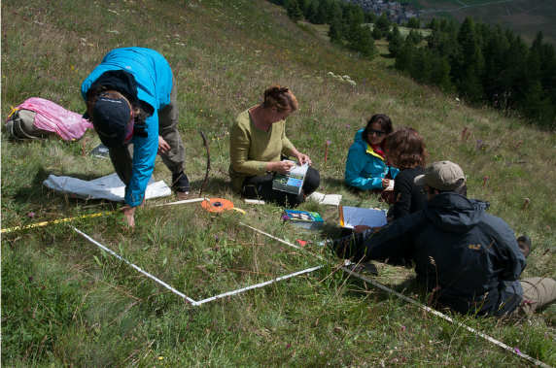
To get an idea of how much you know vs how much you don’t know about the area, scientists use a species accumulation graph. (X-axis= sampling effort (time or area); Y-axis = total # of species).
Figure 1: Species Accumulation Curve
If you graph your results and see you’re in a steep part of the curve, then you know that you will probably find more species with little effort.
If you’re in the flatter part of the curve, then you’ve seen most or all the species in the area, and it might take a lot more effort to find additional species.
Sampling times or area

Measuring Biodiversity Concepts:
- In general, when you spend more time looking, or cover a greater area, you will find more species, until eventually you find all of them.
- If you sample a greater diversity of habitats (i.e. grasslands, forest, streams, mountains), you are likely to find greater number of species. This means greater ecosystem diversity leads to greater biodiversity.
- Each time you sample, the number of newly discovered species decreases.
- When measuring biodiversity, scientists take random samples to avoid bias and replicate samples.
Task:
In this lab students will measure the biodiversity of their area (a small piece of a much larger forest) and create a species accumulation graph.
Pre-lab Question:
The state of Maryland is considering adding an area to the state park system. You are a researcher whose task it is to determine the animal biodiversity of a 100-acre tract of forest. There is no way to sample the entire forest. What would be the best approach to doing this? _________________________________________________
______________________________________________________________________________________
______________________________________________________________________________________
How might having a stream on your tract affect your biodiversity? ________________________________
______________________________________________________________________________________
______________________________________________________________________________________
Procedure:
- Each lab station has a 1-acre plot of the 100-acre forest. It has been subdivided into 32 potential sampling areas.

- Your group will randomly select 10 sampling areas within your 1-acre plot by drawing numbers from a bag (located at your lab station). DO NOT PUT THE NUMBER BACK INTO THE BAG UNTIL YOU ARE DONE WITH YOUR 10 SAMPLES. Please be careful not to lose any numbers.
- For each sampling area, record (in data table 1) the plot #, the type of ecosystem (aquatic or terrestrial or both) and the species of animals you find (not how many).
- Determine the number of new species found with each sampling and record in LAST LINE of data table 1.
- Determine the species accumulation values and record in data table 2.
- Graph SPECIES ACCUMULATION vs SAMPLING #.

Data:
Data Table 1: Species Found
Sampling Number | #1 | #2 | #3 | #4 | #5 | #6 | #7 | #8 | #9 | #10
Plot # (1-32)
Type of Ecosystem
Mammals
Bear
Chipmunk
Deer
Fox
Goat
Moose
Porcupine
Rabbit
Racoon
Skunk
Squirrel
Invertebrates
Bee
Bug (unidentifiable)
Butterfly
Caterpillar
Crab
Dragonfly
Grasshopper
Ladybug
Snail
Birds
Bird (unidentifiable)
Duck (any color)
Owl
Reptile/Amphibian
Frog
Lizard
Snake
Turtle
# new species found

Total # of species found on your 1-acre plot _____________________

DATA ANALYSIS:
Data Table 2: Species Accumulation
Sampling Number | #1 | #2 | #3 | #4 | #5 | #6 | #7 | #8 | #9 | #10
Species Accumulation Values

GROUP SPECIES ACCUMULATION VS SAMPLING CURVE

Post Lab Analysis
- How are genetic diversity, species diversity, and ecosystem diversity different?
________________________________________________________________________________________________________________________________________________________________________________________________________________________________________________
- Why didn’t you get all the species in the first sampling?
________________________________________________________________________________________________________________________________________________________________________________________________________________________________________________
- Based on your graph, do you think you got all (most) the species by the end of tenth sampling? Why or Why not?
_______________________________________________________________________________________________________________________________________________________________________________________________________________________________________
- Discuss why a species accumulation curve is useful.
________________________________________________________________________________________________________________________________________________________________________________________________________________________________________________
- Explain why having a stream on your plot increased the biodiversity of the area. ______________________________________________________________________________________________________________________________________________________________________________________________________________________________________________

