Name: _____________________ Date: ____________ PD: ___________
Reading Tables, Graphs and Figures
Directions: Choice the best answer for each question.
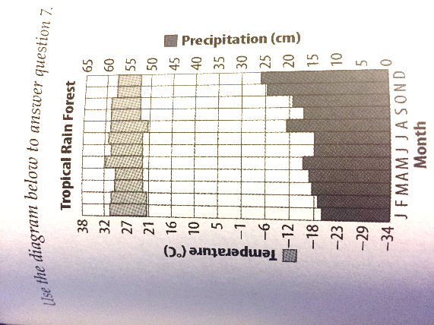
Figure 1. Tropical Rainforest Weather
- According to figure 1, what month(s) did the tropical rain forest have the most rain?
- January and February
- November and December
- May
- August

- According to figure 1, what month(s) did the tropical rainforest have the highest temperatures?
- January and February
- November and December
- May
- August
Figure 2. World Population Growth

- After reviewing figure 2, the enormous increase in human population growth, was most likely due to ____.
- Higher death rates
- Increased marriage rates
- Improvements in medicines, sanitation, and food supplies
- Widespread disease

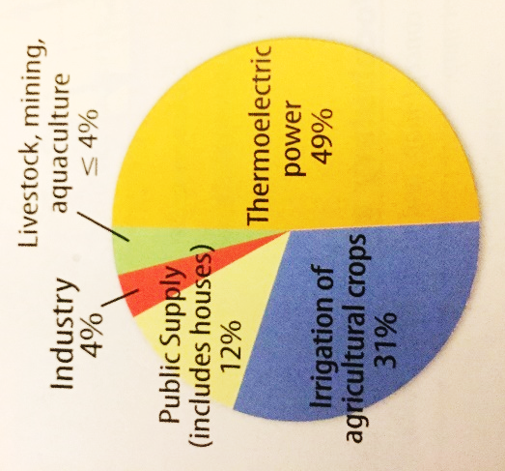
Figure 3. Water use in the United States
- According to figure 3, which is the correct ranking of water use in the United States from least to most?
- Livestock, thermoelectric power, irrigation, public supply
- Livestock, industry, public supply, irrigation and thermoelectric power
- Industry, Public supply, irrigation, thermoelectric power, and livestock
- All the above

Figure 4: Standard Trash Landfill
- What is the function of the well in the figure 4 of a trash landfill?
- To generate electricity
- To monitor quality of groundwater
- To prevent pollution of nearby land
- To treat hazardous water

Figure 5: Waste Disposal
- Using the data in the chart, which circle graph correctly represents waste disposal methods in the United State?
- c.

- d. none of the them

