Rock your Watershed Game
http://water-rocks.herokuapp.com/game/index
STANDARDS
MS-LS2 Ecosystems: Interactions, Energy, and Dynamics
• MS-LS2-5. Evaluate competing design solutions for maintaining biodiversity and ecosystem services.
MS-ESS3 Earth and Human Activity
• MS-ESS3-3. Apply scientific principles to design a method for monitoring and minimizing a human impact on the environment.

HS-LS2 Ecosystems: Interactions, Energy, and Dynamics
• HS-LS2-7. Design, evaluate, and refine a solution for reducing the impacts of human activities on the environment and biodiversity.

TASK: Your watershed is divided into 10 land parcels. Select your land use for each—try to balance both environmental and economic impacts! Your final score is based on balancing profit, nutrients (nitrogen and phosphorus) and sediment (soil) in the water and biodiversity.

NOTE: This game is based on scientific data correlating soil erosion, nutrient transport, precipitation, land management practices, and biological diversity.

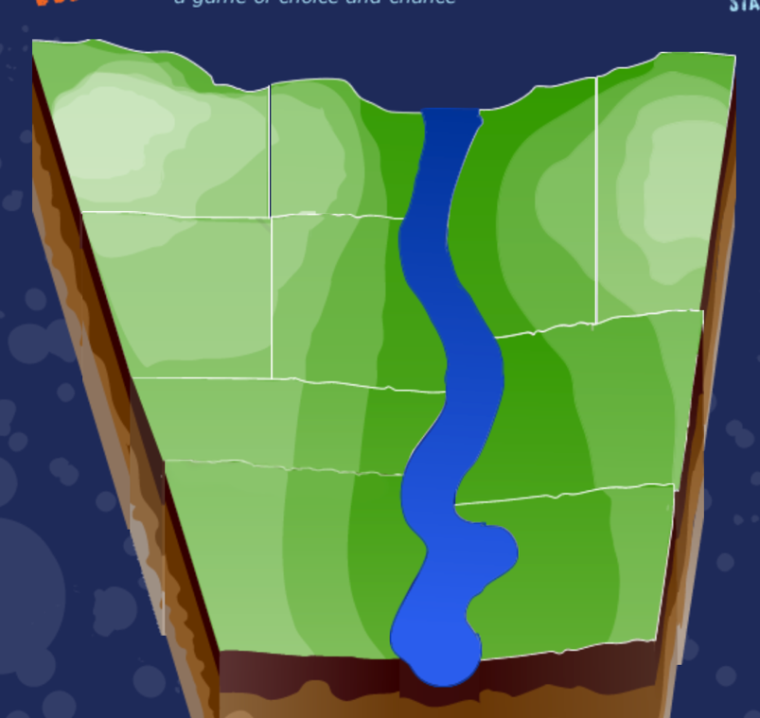:
2
1
3
4
5
6
10
9
8
7

Directions:
- Read the background information and complete the pre-lab questions.
- Get your computers and log into the “Rock your Watershed” game.
- Select the land use for each of the 10 parcels of land and record your data in the respective data table.
- Record your score and rainfall level on the data table.
- Then answer each the two questions at the bottom of each data table.
- Repeat steps 3-5 for two additional trials.
- Answer the post-lab questions in preparation for the final assessment letter.
Background Information
Agricultural Options

Corn/Soybeans cost: $$$$$$
Iowa grows more corn and soybeans than any other state in the United States! Traditionally, corn and soybeans are rotated every other year because the two crops have different nutritional needs.

Corn/Soybeans with buffer: $$$$
Corn and soybeans are rotated every other year. A small amount of land is taken out of production and planted with perennial grasses, called a buffer strip. Buffers can capture sediment and nutrients before they get to nearby streams and rivers.

Corn/Soybeans with wetland cost: $$$$$
Corn and soybeans are rotated every other year. Part of the land area is dedicated to a wetland ecosystem. Wetlands reduce sediment delivery and nutrient transport to streams and rivers, while also providing beauty and habitat on the landscape.

Perennial cover cost: $
Prior to the pioneers expanding west in the 1800s, the Midwest was covered in tallgrass prairie. Revisit the wonders of the prairie ecosystem by restoring perennial grasses and forbs (herbaceous flowering plant) on your land.

Livestock Cost: $$$
Consider diversifying your landscape with the addition of livestock. Good pasture land should have a diversity of perennial plants, including grasses and legumes, that provide forage (food) for beef cattle, dairy cattle, sheep, goats, horses, and other types of livestock.

Rotational cost: $$ In a rotational grazing system, a large pasture is divided into smaller sections called paddocks. Livestock are concentrated on a smaller area of the pasture for a few days, then rotated to a new, fresh section of pasture. This movement allows the grazed paddock a rest period that permits forage to initiate a healthy regrowth, deepen roots, improve yield, and keep the land well-protected from erosion.

Traditional cost: $ Traditional, or continuous, grazing has been the common way to graze livestock over generations. In this arrangement, cattle (or other livestock) graze the same pasture for an extended amount of time. This type of continuous grazing requires less management/lower cost, but can be easily overgrazed, resulting in reduced forage availability/quality, reduced animal growth, and the land becoming more vulnerable to erosion.

Tilling Options

no-till system (no cost)--In a no-till system, the land is left completely undisturbed (never tilled). Corn stalks and bean stubble from the previous year, called residue, are intentionally left out on the land surface, acting like a blanket that protects the soil from erosion. No tilling also means less passes across the field (less fuel cost).

In a strip-till system (cost $)-- the field is left undisturbed other than tilling small strips (6-8 inches wide) where the new seed row will be planted. Strip-till combines the best of both worlds: crop residue protects the land from erosion, while the tilled strips dry and warm up faster for planting in the spring.

In a mulch-till system (cost $$)-- some of the crop residue is buried and the land is turned over after harvest in the fall or before planting in the spring. After tilling, approximately 30% of the land surface is protected by residue (corn stalks or bean stubble). Farmers use mulch till to help the fields dry and warm up more quickly for crop planting in the spring.

Cover crops (cost $$$)-- (including legumes, brassicas, and cereal grains like rye, wheat, and oats) are planted in the same field in the fall to protect the land during the vulnerable winter months.

Fertilizer Rate

Low $-- Nitrogen fertilizer is applied to corn crops to supplement nutrients available in the soil. However, fertilizer can be expensive! Save some money by applying a smaller amount of fertilizer this year…

Medium $$- Nitrogen fertilizer is applied to corn crops to supplement nutrients available in the soil. Agronomy experts at land-grant universities, like Iowa State University, provide recommendations as to the best amount of fertilizer to use each year. Choose this medium amount to follow their recommendations.

High $$$-- Nitrogen fertilizer is applied to corn crops to supplement nutrients available in the soil. Will applying a higher amount of fertilizer help your corn crop get higher yields?

LAND USE

Golf Course cost: $$ Consider adding a golf course to your landscape.

Park cost: $$$ There's something for all ages to enjoy at the park with green spaces for picnics, playgrounds, trails for hiking and biking, as well as soccer, baseball, softball, and more.

Housing cost: $$$$ Where will people live within the watershed? Create housing developments with this option!

Traditional Cost: $$$$ Traditional housing developments are found in most towns and cities across the US - in addition to homes, the space is filled with pavement, sidewalks, streets, and other impermeable surfaces. When rain falls, water quickly runs off to street gutters, curbs, and storm drains that move the rainwater through a series of underground pipes to nearby rivers and streams.

Low Impact cost: $$$$$ Low Impact Development (LID), or "green infrastructure," uses natural processes to slow the flow of water across the urban landscape. Green spaces and permeable surfaces are purposely mixed in with the houses, streets, and sidewalks. Some popular LID practices include the use of more trees, native vegetation, rain gardens, green roofs, rain barrels, and permeable/porous pavement. These practices help to slow the flow of water and also help the water soak into the ground, or infiltrate, rather than quickly running off over the land surface.

Commercial Cost: $$$$$$$$ The commercial option includes restaurants, stores, and shopping malls, providing the opportunity to make some big money within your watershed!

Traditional commercial cost: $$$$$$$ developments are found across the US - outside of restaurants, stores, and shopping malls, the surrounding space is filled with pavement, sidewalks, streets, and other hard impermeable surfaces. Water cannot easily soak into the ground here. Instead, when rain falls here, the water quickly runs off to street gutters, curbs, and storm drains that move the rainwater through a series of underground pipes to nearby rivers and streams.

Low Impact Development (LID) cost: $$$$$$$$$$, or "green infrastructure", uses natural processes to slow the flow of water across the urban landscape. With low impact development, restaurants, stores, and shopping malls are using more green spaces and permeable surfaces around their businesses. Some popular LID practices include the use of more trees, native vegetation, rain gardens, green roofs, rain barrels, stormwater wetlands, and permeable pavers/porous pavement. These practices help to slow the flow of water and also help the water soak into the ground, or infiltrate, rather than quickly running off over the land surface.

Pre-Lab QUESTIONS:
- What is the difference between a traditional house and a low-impact house?
________________________________________________________________________________________________________________________________________________________________________________________________________________________________________________________________________________________________________________________________________________________________________

- What is the difference between a traditional livestock and rotational livestock?
__________________________________________________________________________________________________________________________________________________________________________________________________________________________________________________________________________________________________________________________________________________________________________________________________________________________________________________________________

- Why is the “perennial” optional so inexpensive?
______________________________________________________________________________________________________________________________________________________________________________________________________________________________________________________________________________

- What type of tillage is best for the environment and why?
__________________________________________________________________________________________________________________________________________________________________________________________________________________________________________________________________________________________________________________________________________________________________________________________________________________________________________________________________

TRIAL 1
Section | Land Use | Fertilizer Rate | Tillage
1 | Corn/soybean corn/soybean w/buffer  corn/soybeans w/ wetland, perennial cover,  livestock-traditional livestock-rotational | Low  Medium  High | No till  Strip till  Mulch till  No till with cover crop
2 | Corn/soybean corn/soybean w/buffer  corn/soybeans w/ wetland, perennial cover,  livestock-traditional livestock-rotational | Low  Medium  High | No till  Strip till  Mulch till  No till with cover crop
3 | Corn/soybean corn/soybean w/buffer  corn/soybeans w/ wetland, perennial cover,  livestock-traditional livestock-rotational | Low  Medium  High | No till  Strip till  Mulch till  No till with cover crop
4 | Corn/soybean corn/soybean w/buffer  corn/soybeans w/wetland, perennial cover,  livestock-traditional livestock-rotational | Low  Medium  High | No till  Strip till  Mulch till  No till with cover crop
5 | Corn/soybean corn/soybean w/buffer  corn/soybeans w/ wetland, perennial cover,  livestock-traditional livestock-rotational | Low  Medium  High | No till  Strip till  Mulch till  No till with cover crop
6 | Golf Course  Park  House- Traditional House- low Impact  Commercial-traditional Commercial- low impact
7 | Corn/soybean corn/soybean w/buffer  corn/soybeans w/ wetland, perennial cover,  livestock-traditional livestock-rotational | Low  Medium  High | No till  Strip till  Mulch till  No till with cover crop
8 | Golf Course  Park  House- Traditional House- low Impact  Commercial- traditional Commercial- low impact
9 | Corn/soybean corn/soybean w/buffer  corn/soybeans w/ wetland, perennial cover,  livestock-traditional livestock-rotational | Low  Medium  High | No till  Strip till  Mulch till  No till with cover crop
10 | Golf Course  Park  House- Traditional House- low Impact  Commercial- traditional Commercial- Low impact

SCORE _____________________
Rainfall Level- _____________________

Would your score be higher or lower with more rainfall? _______________
Why do you think this is? ________________________________________________________
_____________________________________________________________________________
_____________________________________________________________________________

TRIAL 2
Section | Land Use | Fertilizer Rate | Tillage
1 | Corn/soybean corn/soybean w/buffer  corn/soybeans w/ wetland, perennial cover,  livestock-traditional livestock-rotational | Low  Medium  High | No till  Strip till  Mulch till  No till with cover crop
2 | Corn/soybean corn/soybean w/buffer  corn/soybeans w/ wetland, perennial cover,  livestock-traditional livestock-rotational | Low  Medium  High | No till  Strip till  Mulch till  No till with cover crop
3 | Corn/soybean corn/soybean w/buffer  corn/soybeans w/ wetland, perennial cover,  livestock-traditional livestock-rotational | Low  Medium  High | No till  Strip till  Mulch till  No till with cover crop
4 | Corn/soybean corn/soybean w/buffer  corn/soybeans w/ wetland, perennial cover,  livestock-traditional livestock-rotational | Low  Medium  High | No till  Strip till  Mulch till  No till with cover crop
5 | Corn/soybean corn/soybean w/buffer  corn/soybeans w/ wetland, perennial cover,  livestock-traditional livestock-rotational | Low  Medium  High | No till  Strip till  Mulch till  No till with cover crop
6 | Golf Course  Park  House- Traditional House- low Impact  Commercial-traditional Commercial- low impact
7 | Corn/soybean corn/soybean w/buffer  corn/soybeans w/ wetland, perennial cover,  livestock-traditional livestock-rotational | Low  Medium  High | No till  Strip till  Mulch till  No till with cover crop
8 | Golf Course  Park  House- Traditional House- low Impact  Commercial- traditional Commercial- low impact
9 | Corn/soybean corn/soybean w/buffer  corn/soybeans w/ wetland, perennial cover,  livestock-traditional livestock-rotational | Low  Medium  High | No till  Strip till  Mulch till  No till with cover crop
10 | Golf Course  Park  House- Traditional House- low Impact  Commercial- traditional Commercial- Low impact

SCORE _____________________
Rainfall Level- _____________________

Would your score be higher or lower with more rainfall? _______________
Why do you think this is? ________________________________________________________
_____________________________________________________________________________
_____________________________________________________________________________

TRIAL 3
Section | Land Use | Fertilizer Rate | Tillage
1 | Corn/soybean corn/soybean w/buffer  corn/soybeans w/ wetland, perennial cover,  livestock-traditional livestock-rotational | Low  Medium  High | No till  Strip till  Mulch till  No till with cover crop
2 | Corn/soybean corn/soybean w/buffer  corn/soybeans w/ wetland, perennial cover,  livestock-traditional livestock-rotational | Low  Medium  High | No till  Strip till  Mulch till  No till with cover crop
3 | Corn/soybean corn/soybean w/buffer  corn/soybeans w/ wetland, perennial cover,  livestock-traditional livestock-rotational | Low  Medium  High | No till  Strip till  Mulch till  No till with cover crop
4 | Corn/soybean corn/soybean w/buffer  corn/soybeans w/ wetland, perennial cover,  livestock-traditional livestock-rotational | Low  Medium  High | No till  Strip till  Mulch till  No till with cover crop
5 | Corn/soybean corn/soybean w/buffer  corn/soybeans w/ wetland, perennial cover,  livestock-traditional livestock-rotational | Low  Medium  High | No till  Strip till  Mulch till  No till with cover crop
6 | Golf Course  Park  House- Traditional House- low Impact  Commercial-traditional Commercial- low impact
7 | Corn/soybean corn/soybean w/buffer  corn/soybeans w/ wetland, perennial cover,  livestock-traditional livestock-rotational | Low  Medium  High | No till  Strip till  Mulch till  No till with cover crop
8 | Golf Course  Park  House- Traditional House- low Impact  Commercial- traditional Commercial- low impact
9 | Corn/soybean corn/soybean w/buffer  corn/soybeans w/ wetland, perennial cover,  livestock-traditional livestock-rotational | Low  Medium  High | No till  Strip till  Mulch till  No till with cover crop
10 | Golf Course  Park  House- Traditional House- low Impact  Commercial- traditional Commercial- Low impact

SCORE _____________________
Rainfall Level- _____________________

Would your score be higher or lower with more rainfall? _______________
Why do you think this is? ________________________________________________________
_____________________________________________________________________________
_____________________________________________________________________________

Post-Lab Questions
- a. List the plants and animals living in one of your ecosystems (the one with the highest score is preferable)?
- Select one organism and describe its role in the ecosystem.
___________________________________________________________________________________________________________________________________________________________________________________________________________________________________________________________________________________________________________________________________________________________________________________________________________________________________________________________________________________________________________________________________________________________

- Draw a food web linking the organisms (plants and animals) found in your ecosystem.

- As a city planner, is it worth investing in environmentally responsible practices? Why or why not?
__________________________________________________________________________________________________________________________________________________________________________________________________________________________________________________________________________________________________________________________________________________________________________________________________________________________________________________________________________________________________________________________________________________________________________________________________________________________________________________________________________________________________________________________________________________________________________________________________________________________________________

- What criteria did you use as you adjusted your layouts?
__________________________________________________________________________________________________________________________________________________________________________________________________________________________________________________________________________________________________________________________________________________________________________________________________________________________________________________________________

- Why is it important to have at least 1 commercial building in your community?
__________________________________________________________________________________________________________________________________________________________________________________________________________________________________________________________________________________________________________________________________________________________________________________________________________________________________________________________________
- Describe at least 2 features that made your “best” ecosystem better than your other ecosystems. State it as a claim! Then give evidence to support it using your data tables and the background information. (For example: My best ecosystem included a ”low impact commercial development”. This type of development has more permeable surfaces, therefore, less runoff occurs. The permeable surfaces allow water to be absorbed into the soil and is filtered in the process.) YOU MAY NOT COPY THIS!
_________________________________________________________________________________________________________________________________________________________________________________________________________________________________________________________________________________________________________________________________________________________________________________________________________________________________________________________________________________________________________________________________________________________________________________________________________________________________________________________________________________________________________________________________________________________________________________________________________________________________________________________________________

Name: ______________________
Assessment:
Your friend has been hired as a city planner (like you) for the neighboring county downriver of your town. Write a letter to your friend giving him/her advice on balancing the needs of the environment with the needs of the local economy.
_____________________________________________________________________________
________________________________________________________________________________________________________________________________________________________________________________________________________________________________________________________________________________________________________________________________________________________________________________________________________________________________________________________________________________________________________________________________________________________________________________________________________________________________________
__________________________________________________________________________________________________________________________________________________________________________________________________________________________________________________________________________________________________________________________________________________________________________________________________________________________________________________________________________________________________________________________________________________________________________________________________________________________________________________________________________________________________________________________________________________________________________________________________
__________________________________________________________________________________________________________________________________________________________________________________________________________________________________________________________________________________________________________________________________________________________________________________________________________________________________________________________________________________________________________________________________________________________________________________________________________________________________________________________________________________________________________________________________________________________________________________________________
____________________________________________________________________________________________________________________________________________________________________________________________________________________________________________________________________________________________________________________
_______________________________________________________________________________________________________________________________________________________________________________________________________________________________________

