Why Do Cave Fish Lose Their Eyes?
by American Museum of Natural History
This article is provided courtesy of the American Museum of Natural History.
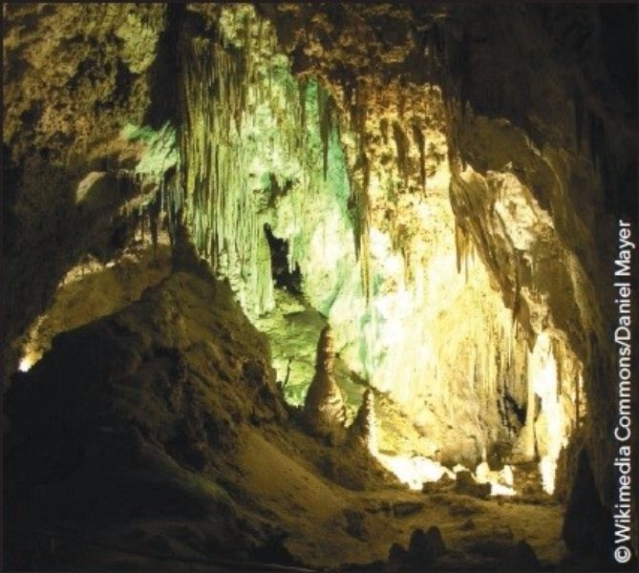
Wikimedia Commons/Daniel Mayer
Carlsbad Caverns National Park
Deep underground there are caves where the sun never shines. If you found yourself in one of these caverns without a flashlight, you would see nothing at all; just total blackness.
In some of these underground caves, there are fishes, crustaceans, salamanders and other animals that have evolved to live without light. For example, more than one hundred species of cave fishes live their lives in constant darkness. They depend on senses other than sight to hunt, eat and reproduce.
Many of these species of fishes are blind or nearly blind-some don't even have eyes. Yet they all evolved from fishes that could see. Somehow, over millions of years, these fishes not only developed the ability to live without sight-they lost the ability to see altogether.
How did that happen? How can evolution cause a species to lose a trait? It's a mystery that evolutionary scientists have been struggling to unravel. The search for an answer gives us a fascinating look at how evolution works.

Regressive Evolution
We usually think of evolution as a process in which species acquire new traits. But in cave fishes we have an example of regressive evolution, a process in which species lose a trait-in this case, the ability to see.
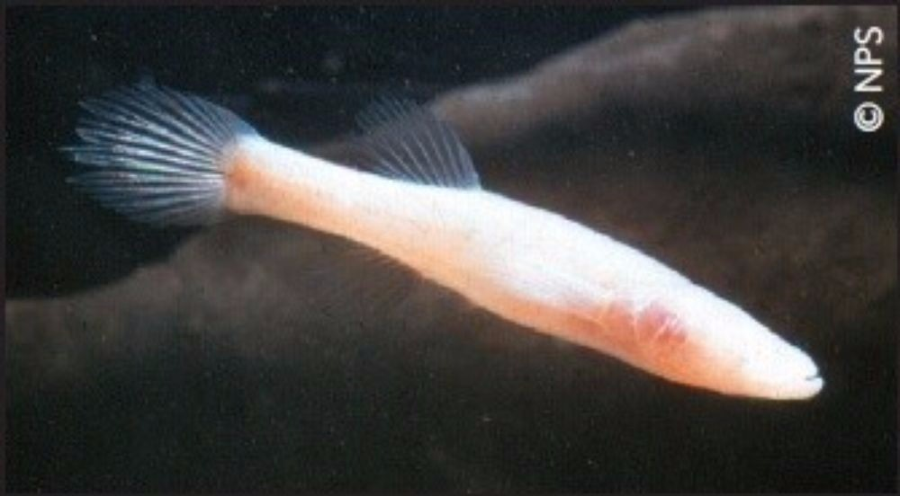
NPS
Blind cave fish, Mammoth Cave National Park, Kentucky
How does this happen? Do cave fishes go blind because they don't use their eyes? Though at first this idea might seem to make sense, it actually has no basis in science. It is your genes that determine which traits you inherit. For example, you have five fingers on each hand because of the genes you got from your parents. However, if you have an accident and lose a finger, your children will still be born with five fingers on each hand. If you lift weights and become a body builder, it doesn't mean your children will be born with bulging biceps. In each case, your genes haven't changed-even though your body has.
The fact that cave fishes don't use their eyes has absolutely no effect on the DNA in their chromosomes.
They are blind because something happened to the genes that control the development of their eyes. This change is passed on from parent to offspring. That explains why a blind fish would have blind offspring. But it doesn't explain how a whole species of blind fish came to exist.
Evolution works by a process called natural selection. If an animal is born with a trait that gives it an advantage over other individuals, it will be more successful at having offspring. When this happens, evolutionary scientists say that that animal is "selected" for having that trait. Its offspring and succeeding generations will inherit that trait, spreading it throughout the population. But in the case of cave fishes, how does being blind give a fish an advantage in the dark? And if being blind is not an advantage, then how did natural selection lead to a species of blind cave fish?

Two Answers
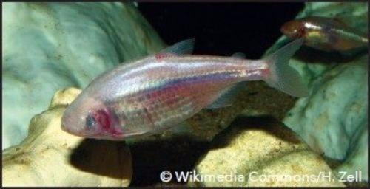
Wikimedia Commons/H. Zell
Mexican tetra (Astyanax mexicanus)
Scientists have studied one species of blind cave fish, the blind Mexican tetra (Astyanax mexicanus). They have come up with competing explanations for blindness in that fish, which likely will help them to understand other cave fishes as well.
The first hypothesis assumes that blindness does give the fish some sort of evolutionary advantage, though not directly. What if the gene or genes that cause blindness also are responsible for some other change in the fish? And what if it was that change, not blindness, that gave the fish an advantage to reproduce? Scientists call this pleiotropy-when multiple effects are caused by the same mutation in one gene.
The second hypothesis is based on the fact that natural selection does not just reward success, it also weeds out failures. In a lake, where there is sunlight, a fish born blind would have trouble competing with other fish that can see. It probably would not survive to have offspring. But a fish born blind in a dark cave would not be at a disadvantage, since in the darkness no fish can use their eyes. In those conditions, natural selection will not work to weed out the mutation for blindness. Over millions of years, many more mutations will accumulate and eventually the entire population of fish will be blind. This is called the neutral mutation hypothesis.

An Eye-Opening Experiment
A group of scientists at the University of Maryland carried out an experiment with two varieties of the same species of Mexican tetras. One variety lives in bodies of water near the surface where there is sunlight and can see. The other variety of tetras lives in dark caves and is blind.
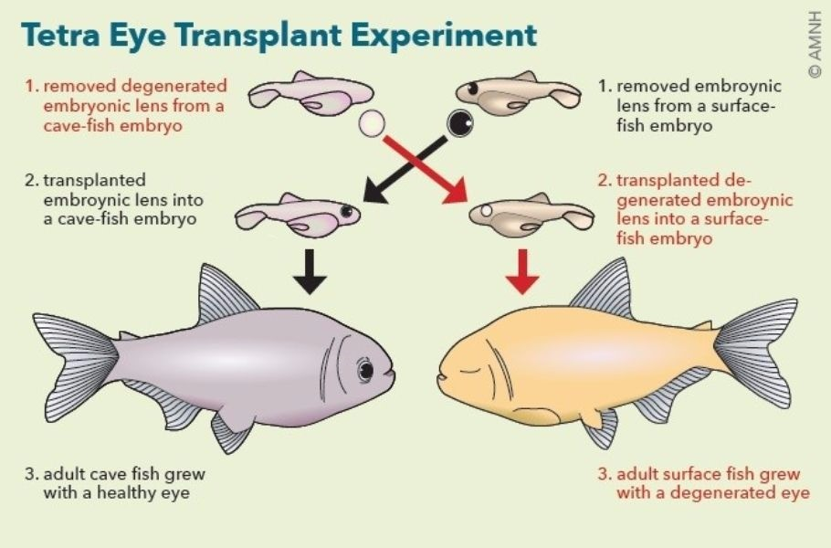
American Museum of Natural History
In their experiment, the scientists transplanted a lens from the eye of a surface tetra embryo into the eye of a cave tetra embryo. The cave-fish embryo would normally develop into a blind fish. But the lens from the surface tetra transplanted into the cave tetra caused all of the surrounding tissues to develop into a healthy eye. This experiment demonstrated that the genes involved in the development of the eyes of the cave tetra were still totally functional.
The scientists knew that there are many genes responsible for the development of each part of an eye (for example, the retina, iris, cornea and lens). Each part develops independently. The results of the experiment showed that the genes for eye development in the Mexican tetra were all ready to work properly, given the correct signal. The experiment seemed to suggest that blindness in the Mexican tetra was not caused by many mutations, but instead by a small number of mutations in genetic "master switches."
These master switches are genes that control the function of many other genes. In this case, the switches control genes responsible for eye development. These master switches have the ability to disable the eye genes. These remain intact, but inactive. Putting a healthy lens into the cave tetra embryo seems to trigger master switches to send a signal to the inactive eye genes, allowing cave tetras to develop eyes.
If scientists could find the genetic "master switches" that made cave tetras blind, they could discover if the same switches had effects on other traits of the fish that do give it an evolutionary advantage for surviving in caves.
The researchers did indeed find one of those genes. It is nicknamed Hedgehog or the Hh gene. They discovered that the Hedgehog gene does more than cause blindness in cave tetras-when the fish develops without eyes, the skull bones move into the empty eye socket, which at the same time enlarges its nose. Unlike other vertebrates, fishes use their nose only for smelling. It could be that the same control gene (Hh) that stops eye development in the fish also enhances its sense of smell. An enhanced sense of smell would be a definite advantage for a fish that lives in darkness.
As a result of these and other experiments, it now seems highly likely that blindness in cave tetras is in part the result of pleiotropy-one mutation that causes blindness in the fish and at the same time, gives them an enhanced sense of smell.

Evolution Works
Scientists are still studying cave fishes, and new discoveries are sure to be found. But one thing is already clear-the answer lies in the basic processes of evolution that are already well understood. With new tools that give scientists the ability to map genes, find specific mutations, and understand the development of embryos, we are increasing our understanding of how evolution works.

Name: ___________________________________ Date: _______________
- What ability have many cave fishes lost?
  - the ability to swim
  - the ability to smell
  - the ability to see
  - the ability to hear
- To organize this text, the author divides it into sections with subheadings. What is described in the section with the subheading "Two Answers"?
  - answers scientists have come up with about why some species of cave fishes are blind
  - answers scientists have come up with about why some caves receive no light from the sun
  - answers scientists have come up with about why some crustaceans have evolved to live without light
  - answers scientists have come up with about why regressive evolution occurs in salamanders
- People's genes determine which traits they inherit.
What information in the article supports this statement?
  - "How did that happen? How can evolution cause a species to lose a trait? It's a mystery that evolutionary scientists have been struggling to unravel. The search for an answer gives us a fascinating look at how evolution works."
  - "We usually think of evolution as a process in which species acquire new traits. But in cave fishes we have an example of regressive evolution, a process in which species lose a trait-in this case, the ability to see."
  - "...you have five fingers on each hand because of the genes you got from your parents. However, if you have an accident and lose a finger, your children will still be born with five fingers on each hand. If you lift weights and become a body builder, it doesn't mean your children will be born with bulging biceps. In each case, your genes haven't changed-even though your body has."
  - "The scientists knew that there are many genes responsible for the development of each part of an eye (for example, the retina, iris, cornea and lens). Each part develops independently. The results of the experiment showed that the genes for eye development in the Mexican tetra were all ready to work properly, given the correct signal."
- Read these sentences from the text.
"The researchers did indeed find one of those genes. It is nicknamed Hedgehog or the Hh gene. They discovered that the Hedgehog gene does more than cause blindness in cave tetras-when the fish develops without eyes, the skull bones move into the empty eye socket, which at the same time enlarges its nose. Unlike other vertebrates, fishes use their nose only for smelling. It could be that the same control gene (Hh) that stops eye development in the fish also enhances its sense of smell. An enhanced sense of smell would be a definite advantage for a fish that lives in darkness."
Based on this information, what can you conclude about the effect that the size of a cave tetra's nose has on the cave tetra's sense of smell?
  - The smaller a cave tetra's nose is, the better the cave tetra's sense of smell will be.
  - The bigger a cave tetra's nose is, the better the cave tetra's sense of smell will be.
  - The size of a cave tetra's nose has no effect on the cave tetra's sense of smell.
  - Any change in the size of a cave tetra's nose will make it more difficult for the cave tetra to recognize smells.
- What is the main idea of this text?
  - More than one hundred species of cave fishes live in constant darkness.
  - If an animal is born with a trait that gives it an advantage over other individuals, it will be more successful at having offspring, and its offspring will inherit the advantageous trait.
  - The neutral mutation hypothesis is based on the fact that natural selection does not just reward success but also weeds out failures.
  - Many cave fishes are blind, and an experiment carried out by scientists suggests that blindness in these fishes is the result of a mutation that also improves their sense of smell.
- The title of this text is "Why Do Cave Fish Lose Their Eyes?" Why might the author have written the title as a question?
  - to prepare readers for a discussion of possible answers to this question in the article
  - to encourage readers to answer the question on their own before they read the article
  - to criticize scientists for not having reached a definite answer about why cave fishes lose their eyes
  - to praise scientists for the effort they have put into understanding the cause of blindness in cave fishes
- Read these sentences from the text.
"The fact that cave fishes don't use their eyes has absolutely no effect on the DNA in their chromosomes. They are blind because something happened to the genes that control the development of their eyes. This change is passed on from parent to offspring. That explains why a blind fish would have blind offspring. But it doesn't explain how a whole species of blind fish came to exist."
How could you rewrite the last sentence without changing its meaning?
  - In particular, it doesn't explain how a whole species of blind fish came to exist.
  - Therefore, it doesn't explain how a whole species of blind fish came to exist.
  - For example, it doesn't explain how a whole species of blind fish came to exist.
  - However, it doesn't explain how a whole species of blind fish came to exist.
- Describe the first hypothesis that scientists have about blindness in the Mexican tetra.
Be sure to discuss pleiotropy in your answer.
___________________________________________________________________________
- One effect of the Hedgehog gene is to make cave tetras go blind. What is another effect it might have?
- As a result of the experiment scientists did with Mexican tetras, it seems likely that their first hypothesis about blindness in the tetras is right. Explain how the result of the experiment supports their first hypothesis. Support your answer with evidence from the text and images.

