Darwin’s Finches Article
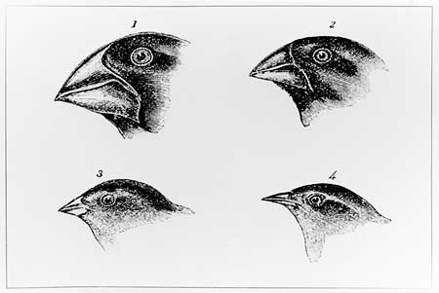
In the Pacific Ocean, 500 miles off the west coast of Ecuador, lay the Galapagos Islands. On the islands, there are over a dozen species of small birds called Darwin’s Finches. The different bird species are all basically the same except for their beaks. Each species’ beak is a different size and shape, and each beak is specialized for the type of food that the bird eats.
Many thousands of years before Darwin arrived on the islands, a small population of finches from Ecuador must have gotten blown over to the Galapagos by a big storm. Once there, the birds split up to different regions of the islands based on how adapted their beaks were able to gather food. Birds with small and narrow beaks either became insect hunters or gathered small seeds; birds with large beaks became the predators of the plants with large seeds. Each group evolved to have significantly shaped beaks. As different beak variations arose over time, the birds continued to evolve into the wide variety of species found there today.

Darwin’s Finches Questions
- Darwin’s finches are a ________ species of small _____________
- Where did Darwin’s finches live? _____________________
- On the map below, mark where the finches live.
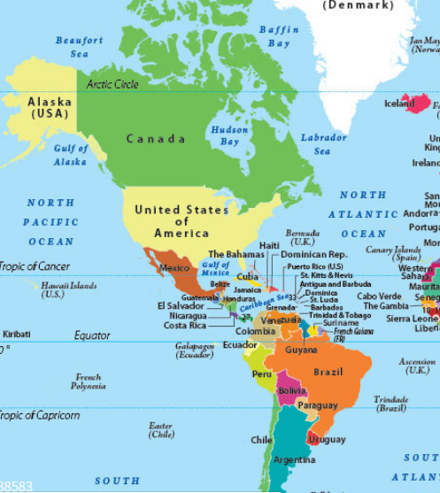
- What made the finch species different? ___________________________________________________________
- Which finches ate insects and small seeds? ________________________________________________________
- Which finches ate large seeds? __________________________________________________
- What is the author’s purpose for writing this article? (Or what does the author explain and why?) _________________________________________________________________________________________________________________________________________________________________________________________________________________________________________________________________________________
- What is the central idea of the passage? __________________________________________________________
___________________________________________________________________________________________
___________________________________________________________________________________________

