Neandertal kids were a lot like kids today — at least in how they grew

Skeleton from almost 8-year-old shows that growth of the child’s brain, spine lagged a bit
BY BRUCE BOWER SEPTEMBER 25, 2017
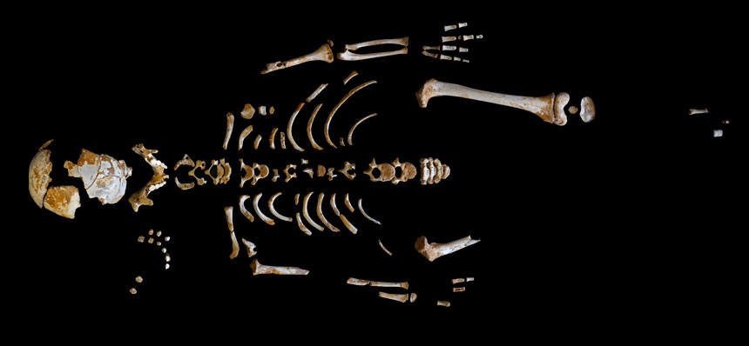
GROW UP A Neandertal’s partial skeleton found in Spain comes from a 7.7-year-old child who grew at a rate much like that of youngsters today, scientists report. However, the ancient youngster displays relatively slow backbone and brain development in comparison with present-day kids.
PALEOANTHROPOLOGY GROUP MNCN-CSIC
A Neandertal child whose partial skeleton dates to around 49,000 years ago grew at the same pace as children do today, with a couple of exceptions. Growth of the child’s spine and brain lagged, a new study finds.
It’s unclear, though, whether developmental slowing in those parts of the body applied only to Neandertals or to Stone Age Homo sapiens as well. If so, environmental conditions at the time — which are currently hard to specify — may have reduced the pace of physical development similarly in both Homo species.
This ancient youngster died at 7.7 years of age, say paleoanthropologist Antonio Rosas of the National Museum of Natural Sciences in Madrid and colleagues. The scientists estimated the child’s age by counting microscopic enamel layers that accumulated daily as a molar tooth formed.
Previous excavations uncovered the child’s remains, as well as fossils of 12 other Neandertals, at a cave site in northwestern Spain called El Sidrόn.
Much — but not all —of the Neandertal child’s skeleton had matured to a point expected for present-day youngsters of the same age, the scientists report in the Sept. 22 Science. But bones at the top and in the middle of the spine had not fully fused, corresponding to a stage of development typical of 4- to 6- year-olds today. Also, the ancient child’s brain was still growing at an age when living humans’ brains have nearly or fully reached adult size. Signs of bone tissue being reshaped on the inner surface of the child’s braincase pointed to ongoing brain expansion. Rosas’ team calculated that the youngster’s brain volume was about 87.5 percent of that expected, on average, for Neandertal adults.
Neandertals’ slightly larger brains relative to people today may have required more energy, and thus more time, to grow, the researchers suggest. And they suspect that the growth of Neandertals’ bigger torsos, and perhaps spinal cords, slowed the extinct species’ backbone development in late childhood.
Rosas’ new study “reinforces what should have been apparent for some time — that Neandertal growth rates and patterns, except for those related to well-known differences in [skeletal shape], rarely differ from modern human variations,” says paleoanthropologist Erik Trinkaus of Washington University in St. Louis.
But researchers need to compare the El Sidrόn child to fossils of H. sapiens youngsters from the same time or later in the Stone Age, Trinkaus adds. Relative to kids today, ancient human youth may display slower growth rates comparable to those of the Neandertal child, he suspects.
Text Dependent Questions:
- What claim does the author make in this article?

- In the 2nd paragraph, what key idea is the author trying to make by comparing Neandertal growth rate to that of Homo sapiens?

- How were scientists able to determine the age of the Neandertal boy’s skeleton?

- What were 2 major differences in the growth rate of the Neandertal child’s skeleton when compared to the growth rate of present day youth?

- Explain why scientists believe that the backbone development of Neandertals took longer than that of present day humans.

