STRUCTURAL BEHAVIORAL FUNCTIONAL
ADAPTATION ADAPTATION ADAPTATION
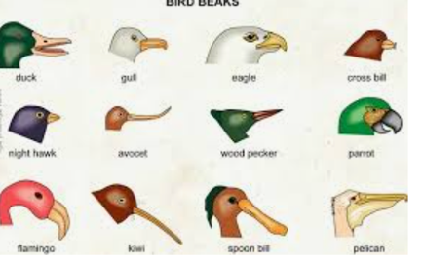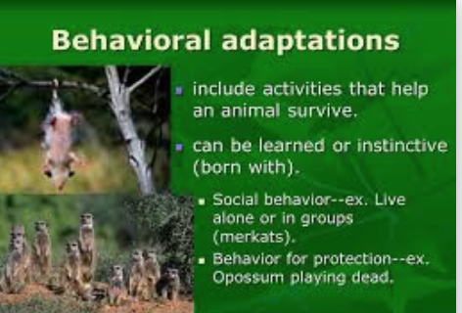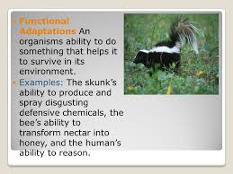

DEFINE: DEFINE DEFINE

EXAMPLES: EXAMPLES: EXAMPLES:

